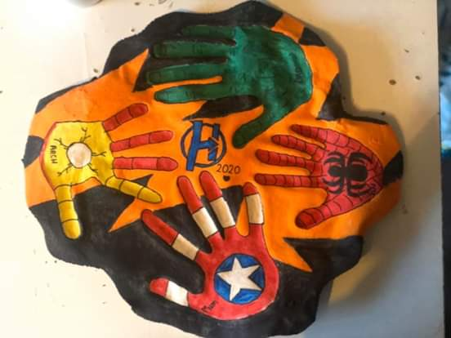

Recipe for salt dough
500gms of plain flour (self raising if you don’t have plain-see guidance on drying below)
250 gms salt
250 ml of water (add slightly more if needed)
Paints and sealant if possible (can use PVA glue and water)

Mix flour and salt and then add water.
Mix into a dough
Roll out onto a flat surface into a desired shape about 1-1.5cm thick. (sprinkle some flour on to make sure it doesn’t stick.)
Place on a baking tray
Make handprints (as deep and clear as possible)
Place in oven on the lowest heat setting possible and leave for 3-4 hours or until completely solid -top and bottom. (alternatively you can leave to air dry for a couple of days in a cool-dry place-this is best option if you use self -raising flour)
Paint if you have colours- acrylic paints are good if you have them.
Seal with any kind of varnish or sealer to preserve it. PVA with water will work if you don’t have any type of varnish. Otherwise take a picture to send to me.
You can do a family one if you want including pets with names or family name on as a keep sake.

