‘oo’ or ‘oo’ sound

*Can you sort the words into 2 different sections?*

|  |  |
| --- | --- |
| *‘oo’ like zoo* | *‘oo’ like hook* |
|  |  |

*Can you explain the difference between the 2 sounds?*

[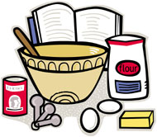](http://www.google.co.uk/url?sa=i&rct=j&q=cook+clip+art&source=images&cd=&cad=rja&docid=etfnOyeaatLRpM&tbnid=0N_RKKPuVSz2NM:&ved=0CAUQjRw&url=http://www.chefjessicabright.com/college-survival-cooking.html&ei=9YAfUZa_BtDFtAbapoCAAg&bvm=bv.42553238,d.Yms&psig=AFQjCNEduLkfT3dFTRtf306kyNiysOyrig&ust=1361105508009215)[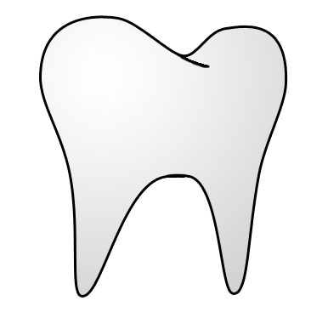](http://www.google.co.uk/url?sa=i&rct=j&q=tooth+clip+art&source=images&cd=&cad=rja&docid=n_tNljeHatOOOM&tbnid=HLK0qB4vTd366M:&ved=0CAUQjRw&url=http://bestclipartblog.com/33-tooth-clip-art.html/tooth-clip-art-2&ei=wIAfUfCAJsfeswasy4HwDA&bvm=bv.42553238,d.Yms&psig=AFQjCNGmpGKC7Sv-hv9c3DOxV0X689T3qg&ust=1361105458105934)[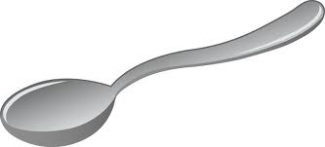](http://www.google.co.uk/url?sa=i&rct=j&q=spoon+clipart&source=images&cd=&cad=rja&docid=REIGmpmvr1h1LM&tbnid=Ztdnw4tXln4dPM:&ved=0CAUQjRw&url=http://sweetclipart.com/silver-table-spoon-556&ei=OIAfUa6gKIbCswa5rIBQ&bvm=bv.42553238,d.Yms&psig=AFQjCNEmUYmOzRqCR0YOZyLFOligkHBtag&ust=1361105326956656)[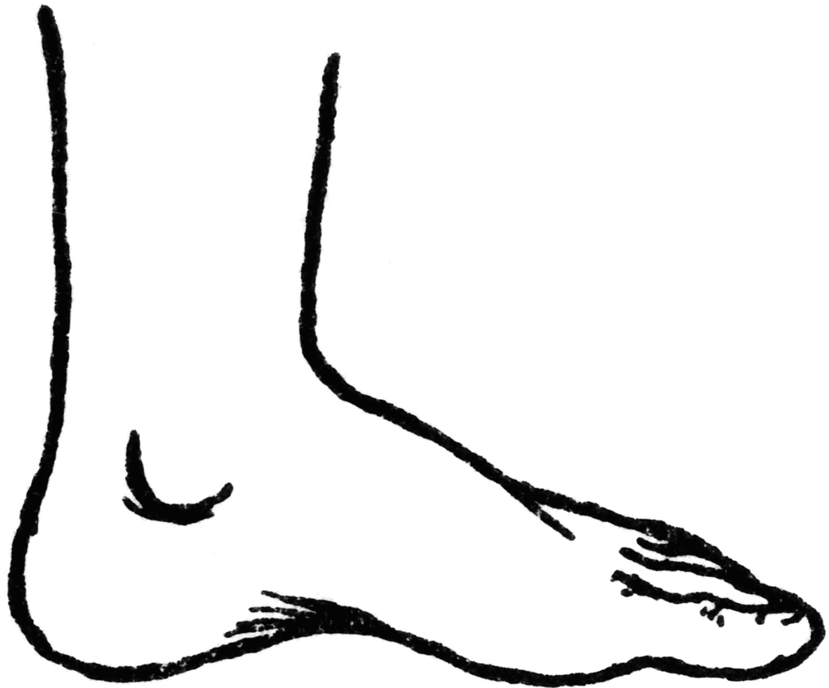](http://www.google.co.uk/url?sa=i&rct=j&q=foot+clipart&source=images&cd=&cad=rja&docid=CP-10J6acn5QyM&tbnid=zZz-go_ISsn3HM:&ved=0CAUQjRw&url=http://etc.usf.edu/clipart/63300/63322/63322_foot.htm&ei=_n8fUbmxKobftAbWiYCQCw&bvm=bv.42553238,d.Yms&psig=AFQjCNF4xx62Z2j0ouUh3vyuKQ0KagP5wg&ust=1361105264210972)[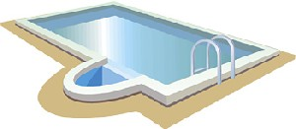](http://www.google.co.uk/url?sa=i&rct=j&q=pool+clipart&source=images&cd=&cad=rja&docid=4fqzgWTUO8AMbM&tbnid=KDvl0j0EIvjTFM:&ved=0CAUQjRw&url=http://www.ccamarlins.com/SubTabGeneric.jsp?team=vacca&_stabid_=70221&ei=xn8fUaabFYT3sgaL-IGwBg&bvm=bv.42553238,d.Yms&psig=AFQjCNFuVK6p2kvYuk2ZrwBFAd651spsZA&ust=1361105212891205)[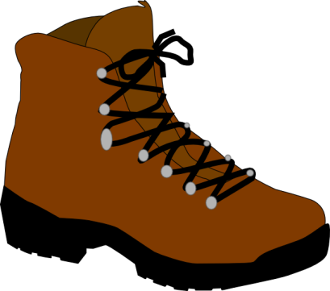](http://www.google.co.uk/url?sa=i&rct=j&q=boot+clipart&source=images&cd=&cad=rja&docid=zMcQP_OjCUUnHM&tbnid=Gl6Wam5TuBdbcM:&ved=0CAUQjRw&url=http://www.clker.com/clipart-4218.html&ei=e38fUZC7ONDFtAbapoCAAg&bvm=bv.42553238,d.Yms&psig=AFQjCNGmOy8tHqg8_kN9UMSL0ep8wr_tXA&ust=1361105140727588)[](http://www.google.co.uk/url?sa=i&rct=j&q=book+clipart&source=images&cd=&cad=rja&docid=q_df9zVvkMRQqM&tbnid=WLgDqhA6VTQfHM:&ved=0CAUQjRw&url=http://www.clipartpal.com/clipart_pd/education/textbooks1.html&ei=Kn8fUauiNsjUsga2m4GQCA&bvm=bv.42553238,d.Yms&psig=AFQjCNFZIKv3UgQDlxOvIghi43tei8YETA&ust=1361105058617734)