Five Children and It – extract
The children have been playing in an old gravel-pit, trying to dig a hole to Australia. Some of the children have grown bored and have drifted off to explore an old cave instead, but Anthea has remained behind, digging the hole.  Anthea suddenly screamed:  “Cyril! Come here! Oh, come quick—It’s alive! It’ll get away! Quick!”  They all hurried back.  “It’s a rat, I shouldn’t wonder,” said Robert. “Father says they infest old places—and this must be pretty old if the sea was here thousands of years ago”—  “Perhaps it is a snake,” said Jane, shuddering.  “Let’s look,” said Cyril, jumping into the hole. “I’m not afraid of snakes. I like them. If it is a snake I’ll tame it, and it will follow me everywhere, and I’ll let it sleep round my neck at night.”  “No, you won’t,” said Robert firmly. He shared Cyril’s bedroom. “But you may if it’s a rat.”  “Oh, don’t be silly!” said Anthea; “it’s not a rat, it’s much bigger. And it’s not a snake. It’s got feet; I saw them; and fur! No—not the spade. You’ll hurt it! Dig with your hands.”  “And let it hurt me instead! That’s so likely, isn’t it?” said Cyril, seizing a spade.  “Oh, don’t!” said Anthea. “Squirrel, don’t. I—it sounds silly, but it said something. It really and truly did”— | “What?”  “It said, ‘You let me alone.’”  But Cyril merely observed that his sister must have gone off her head, and he and Robert dug with spades while Anthea sat on the edge of the hole, jumping up and down with hotness and anxiety. They dug carefully, and presently everyone could see that there really was something moving in the bottom of the Australian hole.  Then Anthea cried out, “I’m not afraid. Let me dig,” and fell on her knees and began to scratch like a dog does when he has suddenly remembered where it was that he buried his bone.  “Oh, I felt fur,” she cried, half laughing and half crying. “I did indeed! I did!” when suddenly a dry husky voice in the sand made them all jump back, and their hearts jumped nearly as fast as they did.  “Let me alone,” it said. And now everyone heard the voice and looked at the others to see if they had heard it too.  “But we want to see you,” said Robert bravely.  “I wish you’d come out,” said Anthea, also taking courage.  “Oh, well—if that’s your wish,” the voice said, and the sand stirred and spun and scattered, and something brown and furry and fat came rolling out into the hole, and the sand fell off it, and it sat there yawning and rubbing the ends of its eyes with its hands.

“I believe I must have dropped asleep,” it said, stretching itself.  The children stood round the hole in a ring, looking at the creature they had found. It was worth looking at. Its eyes were on long horns like a snail’s eyes, and it could move them in and out like telescopes; it had ears like a bat’s ears, and its tubby body was shaped like a spider’s and covered with thick soft fur; its legs and arms were furry too, and it had hands and feet like a monkey’s.  “What on earth is it?” Jane said. “Shall we take it home?”  The thing turned its long eyes to look at her, and said—  “Does she always talk nonsense, or is it only the rubbish on her head that makes her silly?” It looked scornfully at Jane’s hat as it spoke.  “She doesn’t mean to be silly,” Anthea said gently; “we none of us do, whatever you may think! Don’t be frightened; we don’t want to hurt you, you know.”  “Hurt me!” it said. “Me frightened? Upon my word! Why, you talk as if I were nobody in particular.” All its fur stood out like a cat’s when it is going to fight.  “Well,” said Anthea, still kindly, “perhaps if we knew who you are in particular we could think of something to say that wouldn’t make you angry. Everything we’ve said so far seems to have done so. Who are you? And don’t get angry! Because really we don’t know.” | “You don’t know?” it said. “Well, I knew the world had changed—but—well, really—Do you mean to tell me seriously you don’t know a Psammead when you see one?”  “A Sammyadd? That’s Greek to me.”  “So it is to everyone,” said the creature sharply. “Well, in plain English, then, a Sand-fairy. Don’t you know a Sand-fairy when you see one?”  It looked so grieved and hurt that Jane hastened to say, “Of course I see you are, now. It’s quite plain now one comes to look at you.”  “You came to look at me, several sentences ago,” it said crossly, beginning to curl up again in the sand.  “Oh—don’t go away again! Do talk some more,” Robert cried. “I didn’t know you were a Sand-fairy, but I knew directly I saw you that you were much the wonderfullest thing I’d ever seen.”  The Sand-fairy seemed a shade less disagreeable after this.  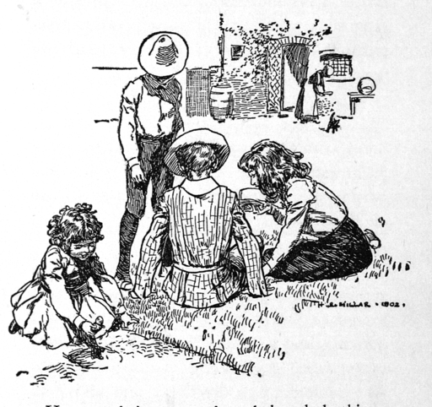

Comprehension questions
Name: Date:

- Which of the children discovers the creature first?

- What reasons does Anthea give that the creature cannot be a snake?

- Why does Robert not want Cyril to sleep with a snake around his neck?

- Why does Anthea try to stop the other children from using the spade to dig?

- Anthea ‘began to scratch like a dog does when he has suddenly remembered where it was that he buried his bone.’

What do you think the author is trying to show with this simile?

- Read the following line from the extract:

‘… suddenly a dry husky voice in the sand made them all jump back, and their hearts jumped nearly as fast as they did.’

What do the words ‘their hearts jumped’ tell you about how the children were feeling?

- The creature says it is called a ‘Sand-fairy’ in English. What is its other name?

- The Sand-fairy says to the children:

“Why, you talk as if I were nobody in particular.”

What do you think it means by this?

- What made the Sand-fairy seem ‘a shade less disagreeable’?

- Find and copy two words in the sentence below that show that the Sand-fairy is upset:

‘It looked so grieved and hurt that Jane hastened to say, “Of course I see you are, now. It’s quite
plain now one comes to look at you.”’

Comprehension answers
- Which of the children discovers the creature first?

Anthea

- What reasons does Anthea give that the creature cannot be a snake?

She says that it cannot be a snake because it has feet and fur.

- Why does Robert not want Cyril to sleep with a snake around his neck?

Because the two boys share a bedroom, and Robert seems to be afraid of snakes.

- Why does Anthea try to stop the other children from using the spade to dig?

Anthea is worried that the spade might hurt the creature.

- Anthea ‘began to scratch like a dog does when he has suddenly remembered where it was that he buried his bone.’ What do you think the author is trying to show with this simile?

Answers should acknowledge that a dog trying to get to its bone would be digging frantically/excitedly. The author is trying to show how excited/focused Anthea is about digging out the creature.

- What do the words ‘their hearts jumped’ tell you about how the children were feeling?

Answers should acknowledge that ‘their hearts jumped’ shows that the children’s hearts were beating faster or skipping a beat, suggesting that the children felt shocked/frightened/excited.

- The Sand-fairy says to the children:

“Why, you talk as if I were nobody in particular.”

What do you think it means by this?

Answers may include one or more of the following: that the creature is somebody important; the creature is shocked that the children don’t know who it is; the creature is offended that the children think it might be frightened.

- The creature says it is called a ‘Sand-fairy’ in plain English. What is its other name?

Psammead.

- What made the Sand-fairy seem ‘a shade less disagreeable’?

Robert calling the Sand-fairy the ‘wonderfullest’ creature he’d ever seen.

- Find and copy two words in the sentence below that show that the Sand-fairy is upset:

‘It looked so grieved and hurt that Jane hastened to say, “Of course I see you are, now. It’s quite plain now one comes to look at you.”’

Grieved and hurt.

