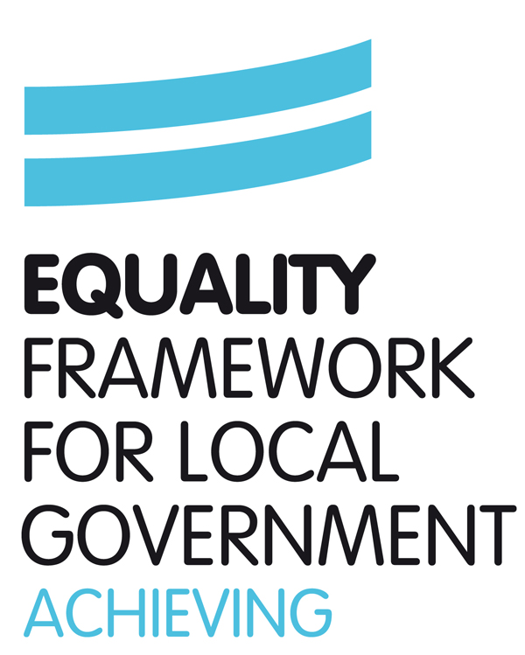
Kirk Smeaton C of E School

Single Equality Scheme 2017

NB
Pink highlight – updated information for 2015
Yellow highlight – school should enter bespoke information related to the school and its context

Introduction

DfE The Equality Act 2010 and schools: Departmental advice for school leaders, school staff, governing bodies and local authorities May 2014
https://www.gov.uk/government/publications/equality-act-2010-advice-for-schools

5.16 Under specific duties set out in previous equality legislation, schools were required to produce equality schemes in relation to race, disability and gender. Under the specific duties there are no requirements to create equality schemes. But schools may choose to continue producing such a scheme, if it helps them to comply with the Equality Duty, and they can expand it to cover the additional protected characteristics.

This Single Equality Scheme for schools in North Yorkshire provides a format for addressing the statutory duties of the Equality Act 2010 and The Children and Families Act 2014 This supersedes and brings together all previous statutory duties in relation to race, gender and disability and also addresses the duty to promote community cohesion, thus meeting the school’s statutory duties in these areas.

The scheme also highlights how our school has worked with and listened to the staff, pupils, parents and carers to inform development of action plans and the need and commitment required to ensure the scheme is a success. This is underpinned by a commitment to promoting positive relationships and understanding between all groups within our school community.
This document sets out how pupils with the following protected characteristics (previously known as equality strands) will be protected in our school from harassment and discrimination:-
- disability.
- gender.
- race.
- religion and belief.
- sexual orientation.
- gender reassignment.
- pregnancy and maternity.
The law on disability discrimination is different from the rest of the Equalities Act in a number of ways. In particular, it works in only one direction – that is to say, it protects disabled people but not people who are not disabled. This means that schools are allowed to treat disabled pupils more favourably than non-disabled pupils, and in some cases are required to do so, by making reasonable adjustments to put them on a more level footing with pupils without disabilities The definition of what constitutes discrimination is more complex. Provision for disabled pupils is closely connected with the regime for children with special educational needs. Chapter 4 of the Act deals in detail with disability issues.
This scheme extends however to cover all aspects of vulnerability, including those associated with socio-economic factors (e.g. pupils from low income families).
As well as delivering high quality services to our pupils, the school is also committed to being a good employer and as such this scheme outlines how we meet our varied duties in terms of recruitment and employment practices. We are also committed to be fully inclusive of all community users, including parents and carers. As such, this scheme therefore also sets out how we will work to overcome any discrimination related to the other protected characteristics:-
- Age*
- Being married or in a civil partnership
*A person’s age is also a protected characteristic in relation to employment and the Act extends this (except for children) to the provision of goods and services, but age as a protected characteristic does not apply to pupils in schools. Schools therefore remain free to admit and organise children in age groups and to treat pupils in ways appropriate to their age and stage of development without risk of legal challenge, even in the case of pupils over the age of 18.

The impact of this scheme is reported on annually.

Signed __________________________ Date______________
Headteacher

Signed___________________________ Date______________
Chair of Governors

Aims of the single equality scheme

- To articulate the school’s commitment to equality which permeates all school policies and practices
- To ensure that everyone who belongs to, or comes into contact with, our school community is valued and respected
- To promote equality of opportunity and eliminate unlawful discrimination, harassment or victimisation
- To comply with statutory duties under equalities legislation in one document

Purpose of the Equality Scheme

This equality scheme is the school’s response to the specific and general duties in the current equality legislation, which has been brought together under the Equality Act 2010 (see appendix 1). It is an attempt to capture how the school is systematically establishing and implementing good practice in equality and diversity across all areas of school life. This includes a response to all aspects of social identity and diversity.

This Equality Scheme sets out how the school will:

- eliminate discrimination
- eliminate harassment or victimisation related to any aspect of social identity or diversity;
- promote equality of opportunity;
- promote positive attitudes to all aspects of social identity and diversity;
- encourage participation by disabled people and people representing different aspects of social identity in public life;
- take steps to take account of difference even where that involves treating some people more favourably than others;
- take proportionate action to address the disadvantage faced by particular groups of pupils.

Planning to eliminate discrimination and promote equality of opportunity

This scheme is underpinned by the core belief that all children and young people belong to their local community and share the same rights to membership of that community and a quality education. We set equality objectives with associated actions which are outlined within our equalities action plan that accompanies this Equality Scheme. Our plan identifies what we will be doing over the coming year to make our school more accessible to the whole community, irrespective of background or need. (see appendix 2)

It encompasses our duties to promote positive outcomes in relation to race, gender and disability, but also identifies actions to address other social identities. It encompasses our anticipatory duties to plan ahead for the reasonable adjustments (reasonable and proportionate steps to overcome barriers that may impede some pupils) we need to make to be best placed to help disabled pupils who come to our school.

This action plan replaces the school’s Disability Accessibility Plan for the school (previously required under the planning duties in the Disability Discrimination Act) as it sets out how the school will increase access to education for disabled pupils, alongside other protected groups, in the three areas required:
- increasing the extent to which disabled pupils can participate in the school curriculum;
- improving the physical environment of the school to enable disabled pupils to take better advantage of education, benefits, facilities and services provided
- improving the availability of accessible information to disabled pupils.

The action plan is renewed annually and progress towards the equality objectives within it is reported on regularly to governors, and this information is published at least annually. Equality objectives have been identified through consultation with key stakeholders using the Inclusion Quality Mark audit tool. Our equality objectives are published at least once every four years.
This action plan is understood and implemented by all staff and is available on the school website. It is available in different formats and in different languages on request to the school office.
Our school has regard to the need to provide adequate resources for implementing plans and must regularly review them. (NB An accessibility plan may be a freestanding document but may also be published as part of another document such as the school development plan.)
OFSTED inspection may include the school’s accessibility plan as part of their review.
Equality Objectives 2015-19
Sample objectives:

- to narrow the gap in performance of disabled pupils;
- to increase understanding between religious groups;
- to maintain the low number of homophobic incidents;
- to raise attainment in English for boys;
- to encourage girls to consider non-stereotyped career options;
- to anticipate the needs of incoming pupils from a new group, such as traveller children.

School Aims Statements

Indicators of progress towards meeting objectives

School Vision and Values

The school’s vision and values statement reflects the school’s ambitions for all its pupils and have been developed with the whole community. It refers to the key requirements set out in the National Curriculum Inclusion Statement for developing an inclusive curriculum: setting suitable learning challenges; responding to pupils’ diverse learning needs; overcoming potential barriers to learning and assessment for individuals and groups of pupils.

The school statement also embraces the North Yorkshire Inclusion statement which emphasises that individuals and groups of learners who may be vulnerable to exclusion, marginalisation and underachievement are identified and receive targeted provision to ensure their presence, participation and achievement. The school is committed to achieving the Inclusion Quality Mark and to addressing any actions which are identified to improve our inclusive practice.

School Context
The nature of the school population and context to inform action planning for the equality scheme
Factors of the geographical location of the school:-

E.g. the community served (pupils, staff, parents/carers, wider community):-
1% minority ethnic;
1% religions and belief; Hindu
1% languages spoken; Russian
7% Free School Meals (FSM) – eligibility and uptake;100%
10% Special Educational needs (SEN);
0% Disabled;
2 % New Arrivals;
0% Asylum Seekers
50% gender; girls/boys
% sexual orientation; N/A
The turnover of pupils and staff; average
The nature of the school intake in the future (bearing in mind the anticipatory requirement of the DDA).Is from a semi-rural farming community
The nature of the school and site regarding access;
Languages spoken at the school; Mainly English ( 1 pupil speaks Russian)
Recruitment, development and retention of staff against social identity factors such as disability, gender, sexual orientation, faith, age, ethnicity-When appointing staff we follow NYCC HR Equality policies.

The training taken to position the school well for the equality and diversity agenda.

Meeting the medical needs of pupils-this is reviewed at weekly meetings with between the head teacher & the Admin Assistant responsible for health & Safety; Restrictive Physical Intervention INSET is up to date; use of pejorative languages monitored and reported to the LA; Induction procedures are followed for new intake for ALL staff (SENCO updates) including medical, faith and belief, language needs; There is a standing agenda item on all staff meetings, Governing Body meetings; themed weeks for pupils are taught every year during ‘National Anti-Bullying Week, The Health & Safety Committee scrutinize the ‘Accident Book’ for equal opportunities; governor training on fair recruitment practices follows LA guidelines; use of the Inclusion Development Programme by the Head teacher is in place. Weekly scrutiny of attendance figures for vulnerable learners is carried out. governor training on fair recruitment practices; training on the new SEND Code of Practice 2014 ;

E

School provision
Examples of reasonable adjustments the school makes as a matter of course

From September 2012 schools and local authorities have a duty to supply auxiliary aids and services as reasonable adjustments where these are not being supplied through Special Educational Needs (SEN) statements or from other sources. Additional high needs funding may be available on application to the local authority.

-Information is currently provided for disabled pupils & parents/carers; parents with weak literacy skills are telephoned at parents evenings. The SEN Code of Practice is followed and information is shared at termly reviews with SENCO, parents, teachers, outside agencies and pupils
- Steps that have been taken to create communication friendly/dyslexia friendly environments; The dyslexia award was given in 2011
- The school operates a differentiated behaviour policy; The behaviour policy is clear & followed consistently by all members of staff.
- ‘Provision Maps’ are in place for different areas of need (e.g. dyslexia, behaviour, autism, English as an additional language)

Outcomes for pupils

Outcomes for pupils are analysed against social identity issues, i.e. gender, ethnicity, disability, faith background, and aspects of vulnerability identified by the school. This is compared with the outcomes made for all pupils. This is recorded in the School Self evaluation Form (SEF).

These processes form part of the school’s equality impact assessment processes through the Inclusion Quality Mark, to determine the impact of our provision on improving outcomes for identified pupils. In line with statutory requirements all new policies as well as existing policies and functions are evaluated for the impact they have, in consultation with identified pupils and parents/carers.

- pupils’ attainment - analysis of end of key stage results for pupils of particular groups (See evidence ; Raiseonline,SEF n.b anonymous data can be given on request)
- the quality of particular groups of pupils’ learning and the progress they make throughout the school (See evidence ; Raiseonline,SEF, Pupil Premium tables[school web site] n.b anonymous data can be given on request)
- the extent to which different groups of pupils feel safe (e.g. Incidents of racism, ‘hate’ and bullying involving particular groups of pupils-these are reported to the LA on a termly basis)
- the behaviour of particular groups of pupils e.g. exclusion data for particular groups of pupils(See evidence ; Raiseonline,SEF n.b anonymous data can be given on request)
- the extent to which pupils from particular groups adopt healthy lifestyles (See evidence ; Raiseonline,SEF n.b anonymous data can be given on request)
- the extent to which pupils from particular groups contribute to the school and the wider community (See evidence ; Raiseonline,SEF n.b anonymous data can be given on request)
- attendance data for all pupils and for particular groups (See evidence ; Raiseonline,SEF n.b anonymous data can be given on request)
- the effectiveness of the school’s engagement with parents/carers of particular groups of pupils (See evidence ; Raiseonline,SEF, n.b anonymous data can be given on request) results of parental feedback)
- impact of the use of specific individual budgets e.g. Pupil Premium report SEN information report
Roles and Responsibilities in Implementing the Single Equality Scheme

The Head Teacher will:

- ensure that staff and parents are informed about the Single Equality Scheme;
- ensure that the scheme is implemented effectively;
- manage any day to day issues arising from the policy whether for pupils or for the school as an employer;
- ensure staff have access to training which helps to implement the scheme;
- liaise with external agencies regarding the policy so that the school’s actions are in line with the best advice available;
- monitor the scheme and report to the Governing Body at least annually, on the effectiveness of the policy;
- ensure that the SLT are kept up to date with any development affecting the policy/action plan arising from the scheme;
- provide appropriate support and monitoring for all pupils and specific and targeted pupils to whom the scheme has direct relevance, with assistance from relevant agencies.

The Governing Body will:

- ensure that the school complies with all relevant equalities legislation;
- recommend all governors receive up to date training in all the equalities and SEND duties;
- designate a governor with specific responsibility for the Single Equality Scheme;
- establish that the action plans arising from the scheme are part of the School Development Plan;
- support the Headteacher in implementing any actions necessary;
- inform and consult with parents about the scheme;
- evaluate and review the action every three years;
- evaluate the action plan annually
- publish information at least annually.
- publish equality objectives every four years

The Senior Leadership Team will:

- have general responsibility for supporting other staff in implementing this scheme;
- provide a lead in the dissemination of information relating to the scheme;
- identify good quality resources and CPD opportunities to support the scheme;
- with the Headteacher, provide advice/support in dealing with any incidents/issues;
- assist in implementing reviews of this scheme as detailed in the School Development Plan.

People with specific responsibilities SENCO

- details of the person responsible for maintaining and sharing with all the staff those vulnerable pupils and how their needs will be met;
- details of the person responsible for ensuring the specific needs of staff members are addressed;
- details of the person responsible for gathering and analysing the information on outcomes of vulnerable pupils and staff;
- details of the person responsible for monitoring the response to reported incidents of a discriminatory nature.
- details of the governor responsible for publishing the SEN information report

Parents/Carers will:

- have access to the scheme;
- be encouraged to support the scheme;
- have the opportunity to attend contribute to the development of the scheme;
- have the right to a personalised approach to meeting additional needs and a right to have their views taken into account.
- have the right to be informed of any incident related to this scheme which could directly affect their child.

School Staff will:

- accept that this is a whole school issue and support the Single Equality Scheme;
- be aware of the Single Equality Scheme and how it relates to them;
- make known any queries or training requirements
- know how to deal with incidents of concern, including bullying and how to identify and challenge bias and stereotyping;
- know procedures for reporting incidents of racism, harassment or other forms of discrimination;
- not discriminate on racial, disability or other grounds;
- keep themselves up to date with relevant legislation and attend training and information events organised by the school or LA;
- ensure that pupils from all groups are included in all activities and have full access to the curriculum;
- promote equality and diversity through teaching and through relations with pupils, staff, parents, and the wider community.

Pupils will:

- be encouraged to express their views and contribute where possible to the formulation of policies
- be made aware of any relevant part of the scheme, appropriate to age and ability;
- be expected to act in accordance with any relevant part of the scheme
- experience a curriculum and environment which is respectful of diversity and difference and prepares them well for life in a diverse society;
- understand the importance of reporting discriminatory bullying and racially motivated incidents;
- ensure the peer support programme within the school promotes understanding and supports pupils who are experiencing discrimination.

Visitors and contractors are responsible for complying with the school’s Equality Scheme – non-compliance will be dealt with by the Headteacher.

Involvement Processes

Policies are vital to identify and consolidate thinking regarding appropriate provision for pupils, however, they are often viewed as an end, when they should be seen as a process - always evolving in response to changes and evidence from impact assessments. When developing this Equality Scheme, the school is clear that this is a process which must be informed by the involvement of all participants such as pupils, parents, school staff, governors and external agencies. This will ensure that the school gleans insights into the barriers faced by people from different social identity backgrounds and learns the best ways to overcome such barriers. This Scheme will be informed, therefore, by:

- the views and aspirations of pupils themselves from different social identity backgrounds;
- the views and aspirations of parents of pupils from different social identity backgrounds;
- the views and aspirations of staff from different social identity backgrounds;
- the views and aspirations of members of the community and other agencies, including voluntary organisations, representing different social identity backgrounds;
- the priorities in the North Yorkshire Children and Young People’s Plan.

Mechanisms for involvement

At this school the following mechanisms will ensure the views of pupils inform the Equality Scheme and action plan:
e.g.
- Exit interviews with pupils;
- School council;
- Twice yearly focus groups of pupils representing different social identity backgrounds, i.e., gender forum, disability forum;
- E-forums;
- Individual interviews with pupils involved in incidents of a discriminatory nature or bullying related to discrimination;
- Individual interviews with pupils experiencing reasonable adjustments;
- Yearly open meetings representing a particular theme shared with the community and cluster of schools.
- Growing Up in North Yorkshire Pupil Survey

At this school the following mechanisms will ensure the views of staff inform the Equality Scheme and action plan:
e.g.
- Exit interviews with staff;
- Regular meetings with union representatives;
- E-forums;
- Regular staff meetings with specific agenda items;
- Individual discussions with staff as a part of performance management.

At this school the following mechanisms will ensure the views of parents and the community inform the Equality Scheme and action plan:

e.g.

- Welcoming parents and the community into school so that they are critical drivers in policy development.
- Text to be inserted into communication with parents: “your support for your child’s education is crucial to their progress. Please tell us if there is any adjustments we need to make to help you support your child, for example: letters in large font; letters in different languages; wheelchair access; explaining things over the phone; a discussion with a school colleague of the same gender.”
- Feedback through the Governing Body meetings;
- Feedback through the PTA meetings;
- Feedback from adults using the school beyond the school day;
- Yearly open meetings with parents and local groups representing a particular theme.
The school’s action plan will focus on developing the involvement of pupils, staff and parents from different social identity backgrounds over the three years of this Scheme. We will consider varying the times, methods and the venues for this involvement to ensure the best possible attendance and ensure views can be heard. This way the school will learn what works and the involvement of pupils, staff and parents will improve and deepen over time.

Making it happen

Action Planning

Although it is no longer a requirement for schools to have an equality action plan, those schools which do already have one (or more) of these in place, may find it helpful to continue with this approach and adapt it to take into account the extent of the duty.( 5.27 DfE Equalities Guidance May 2014)

This scheme is supported by an action plan, the progress of which is monitored and evaluated by the Governing Body.

The action plan that identifies the equality objectives for the school arising from this scheme and the impact assessment through the Inclusion Quality Mark has:
- clear allocation of responsibility;
- clear allocation of resources, human and financial;
- clear timescales;
- expected outcomes and performance criteria;
- specified dates for review;

The effectiveness of this Scheme will be evaluated and reflected in:
- the School Self-evaluation Form;
- the level achieved in the Inclusion Quality Mark;
- feedback e.g. Parentview

Reporting

This Scheme will be reported on annually. Progress against the action plan will be evaluated and the impact of the action and activities assessed. Copies will be displayed in the school reception area and it will be referenced in school newsletters and in the school’s prospectus, school website.

Publication

This Equality Scheme will be published and available to anyone requesting a copy. Copies will be displayed in the school reception area and it will be referenced in school newsletters, the school prospectus and on the school’s website.
Information is published demonstrating how the school is complying with the Public Sector Equality Duty and the school’s equality objectives. The school updates its published information at least annually and publishes the equality objectives at least every four years.

It will be up to schools themselves to decide in what format they publish equality information. For most schools, the simplest approach may be to set up an equalities page on their website where all this information is present or links to it are available. The regulations are not prescriptive and it will be entirely up to schools to decide how they publish the information, so long as it is accessible to those members of the school community and the public who want to see it. (5.25 DfE Equalities Guidance May 2014)

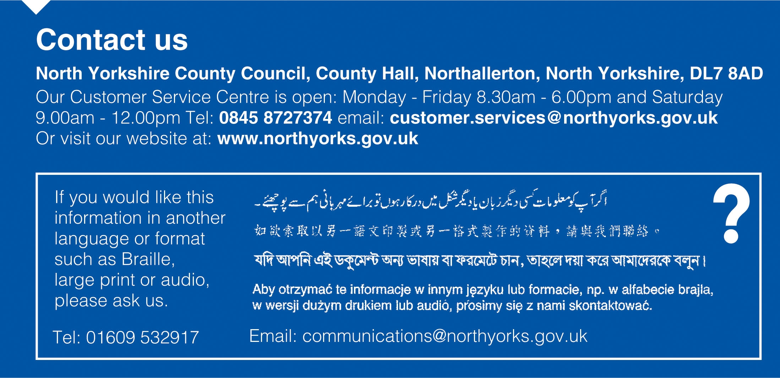

Appendix 1
Equality Legislation and Guidance

This equality scheme responds to the current equalities legislation.

- The Equality Act 2010 is the overarching legislation for all equality duties.

The act serves two main purposes:

- To harmonise discrimination law;
- To strengthen the law to support progress on equality.

The act supersedes or strengthens the following acts and regulations:

- The Equal Pay Act 1970
- The Sex Discrimination Act 1975
- The Race Relations Act 1976
- The Disability Discrimination Act 1995
- The Employment Equality (Religion & Belief and Sexual Orientation) Regulations 2003
- The Employment Equality (Age) Regulations 2006
- The Equality Act 2006 Part 2
- The Equality Act (Sexual Orientation) Regulations 2007
- The SEN Code of Practice 2001

Overview of previous equalities legislation which has been harmonised and strengthened by Equality Act 2010:

- Race Relations Act (RRA) 1976/2000
statutory positive duty to promote racial equality, promote good race relations and eliminate unlawful racial discrimination;

- Sex Discrimination Act (SDA) 1975 (and Regulations 1999), Gender Equality Duty 2007
statutory positive duty to promote gender equality and eliminate unlawful gender discrimination;

- Employment Equality (religion or belief) (sexual orientation) Regulations 2003 extended to education, Equality Act (Part 2) 2007
The Act sets out that is unlawful for schools to discriminate against a person:
a) in the terms on which it offers to admit him/her as a pupil:
b) by refusing to accept an application to admit him/her as a pupil, or
c) where he/she is a pupil of the establishment:
i) in the way in which it affords him/her access to any benefit, facility or service,
ii) by refusing him/her access to a benefit, facility or service,
iii) by excluding him/her from the establishment,
iv) by subjecting him/her to any other detriment.

- Disability Discrimination Act (DDA) 1995/2005
statutory positive duty to promote equality of opportunity for disabled people: pupils, staff, parents, carers and other people who use the school or may wish to, and eliminate unlawful discrimination;
- Education and Inspections Act 2006, duty to promote community cohesion.
By ‘community cohesion’ the school is endorsing and adopting the definition provided by Alan Johnson, 2006, as:
”working towards a society in which there is a common vision and sense of belonging by all communities; a society in which the diversity of people’s backgrounds and circumstances is appreciated and valued; a society in which similar life opportunities are available to all; and a society in which strong and positive relationships exist and continue to be developed in the workplace, in schools and in the wider community.”

Essential Further Guidance

DfE The Equality Act 2010 and schools: Departmental advice for school leaders, school staff, governing bodies and local authorities (May 2014)
https://www.gov.uk/government/publications/equality-act-2010-advice-for-schools

Equality and Human Rights Commission Guidance for schools
http://www.equalityhumanrights.com/advice-and-guidance/education-providers-schools-guidance

SEND Code of Practice January 2015- latest at 01.03.15 and effective from 01.04.15
https://www.gov.uk/government/uploads/system/uploads/attachment_data/file/398815/SEND_Code_of_Practice_January_2015.pdf

Appendix 2
Equality Action Plans

KEY ISSUE
Improving access to the curriculum: (short term)

Success criteria
- Raised confidence of staff in strategies for differentiation and increased pupil participation.
- Raised confidence of TAs as above.
- All staff aware of individual pupils’ access needs.

Actions to achieve the success criteria | Persons responsible for delivering the action | Start date | Finish date | Costs borne by the school | Monitoring Person and Method | Notes on progress
Increase confidence of staff in differentiating the curriculum.  - Undertake audit of staff training needs on curriculum access,  - Assign in-service day to training identified e.g. dyslexia, differentiation, alternative recording, IDP. | SENCo  Headteacher | Jan 16 | By July 2018 |  | Designated Governor
Ensure TAs have access to specific training on disability issues.  - Use staff audit to identify TA training needs and inform Professional Development process.  - TAs to access at least 6 relevant CPD courses each year. | SENCo | From Jan 16 | By July 2018 |  | Designated Governor and HT
Ensure all staff are aware of disabled children’s curriculum access.  - Set up system of individual access plans for disabled children.  - Set up system for information to be shared with appropriate staff. | SENCo | From Jan 16 | July 17 |  | Designated Governor and HT

KEY ISSUE
Improving access the curriculum (medium term)

Success criteria:
- All children in school able to access all school trips and take part in range of activities.
- All children able to access PE and disabled children more able to excel in sports.
- Gradual introduction of disability issues into all curriculum areas,

Actions to achieve the success criteria | Persons responsible for delivering the action | Start date | Finish date | Costs borne by the school | Monitoring Person and Method | Notes on progress
Ensure all school trips and camps are accessible to all.  - Develop guidance for staff on making trips accessible.  - Investigate new camp location that is accessible for next year. | Headteacher | Summer 2016 | By March 2018 |  | Designated Governor
Review PE Curriculum to make PE accessible to all.  - Gather information in accessible PE and Disability Sports  - Invite disabled sports people in for particular sessions.  - Review PE curriculum to include disability sports. | PE Coordinator | From Jan 16 | By July 18 |  | Designated Governor and HT
Review all curriculum areas to include disability issues.  - Include specific reference to disability equality in all curriculum reviews.  - Develop Personal, Social, Health and Citizenship Education (PSHCE) curriculum to address disability equality issues.  - Assemble resource box of disability equality for staff room (primary)  - Have section on disability equality and curriculum access planning sheets. | Headteacher/Subject leaders  PSHCE  Coordinator  PSHCE Coordinator  Headteacher/Subject leaders | From Jan 16  From Jan 16 | By July 2018  By Jan 2018 |  | Designated Governor and HT

KEY ISSUE
Improving access to curriculum (long term)

Success criteria:
All staff confident and consistent in range of differentiation strategies and use of alternative recording.
Disabled children confident and able to participate equally in out of school activities.
All staff work from a disability equality perspective.
Increased confidence of staff in developing their curriculum area accessibly.
Improved involvement of TAs in planning and evaluation of lessons

Actions to achieve the success criteria | Persons responsible for delivering the action | Start date | Finish date | Costs borne by the school | Monitoring Person and Method | Notes on progress
Develop consistent approach to differentiation and alternative recording in school.  - Devise and consult on model school policy with good practice guidance.  - Organise 2 INSET sessions to share good practice. | SENCo  SENCo |  | By July 2018  By July 2018 |  | Designated Governor and HT
Ensure disabled children participate equally in after school and lunch time activities.  - Survey participation in clubs at lunch and after school by disabled children.  - Organise additional activities for excluded pupils. | Identified Year 6 teacher. |  | By March 2018 |  | Designated Governor and HT
Ensure all staff have undertaken disability equality training.  - Set up Inset training for all staff on disability equality, explore support from Special Schools.  - Ensure new staff access similar CPD courses. | CPD Coordinator | DEC 2014 | By March 2018 |  | Designated Governor and HT
Develop system for involving TAs in curriculum planning.  - Establish joint TA/teacher planning opportunities.  - Set up system for joint TAs/teacher evaluations. | SENCo | From 2016 | By March 2018 |  | Designated Governor and HT

