Week 6 - Thursday Challenge
Perimeter of a Rectangle
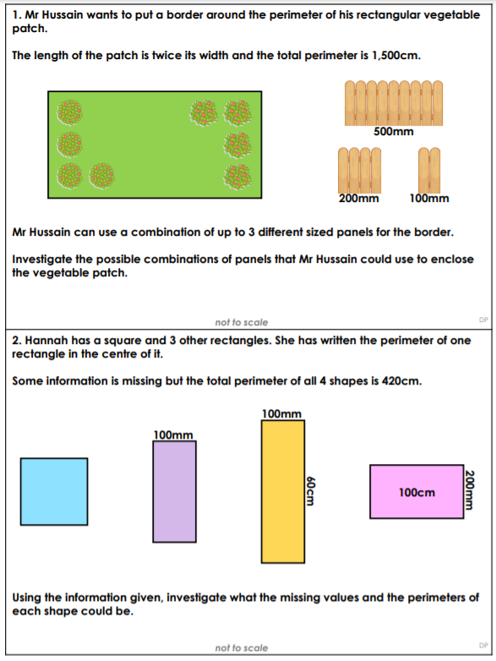

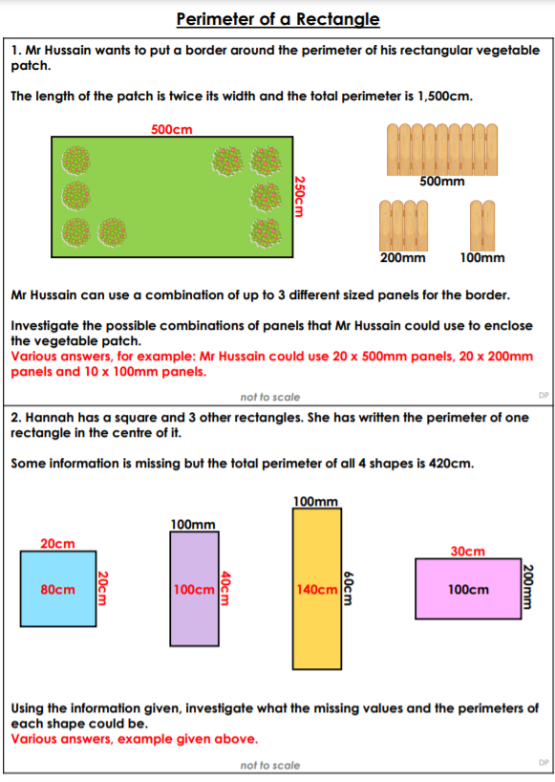
Thursday – Answers

