WEEK 6 - Monday Maths Challenge
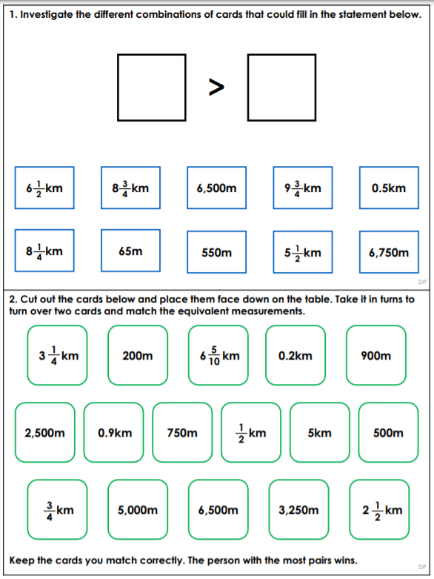
Kilometres

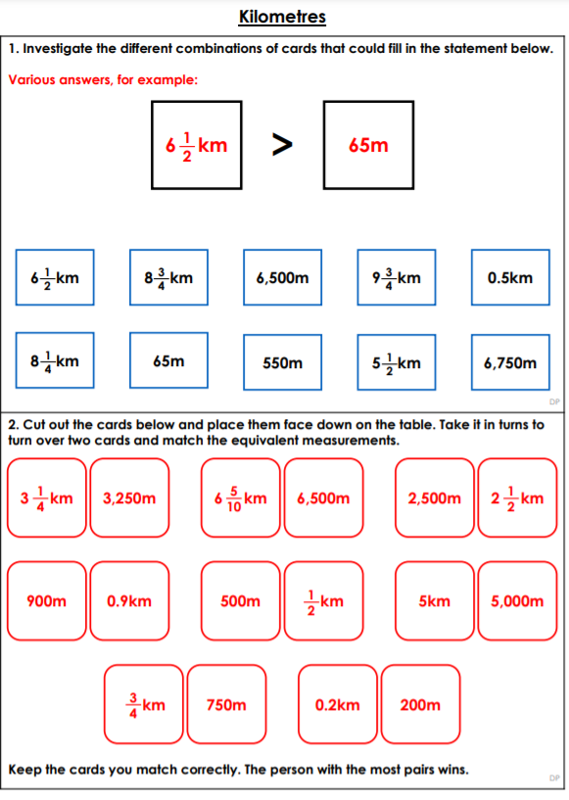
Monday – Answers

