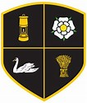 | 5-Day Active Challenge
Day  1 | MONDAY – STRIKING CHALLENGE  Get some items to use as a bat –  kitchen pan, rolling pin, chopping board and an actual bat if you have one.  Set out a marker as a starting line then using a tennis ball or some rolled up socks to see if you can throw them up in the air and hit them.  Which item works best for you? How far can you get the ball or socks to go? | 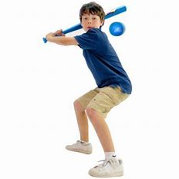
Day  2 | TUESDAY – FUN FITNESS VIDEO  Today have a go at one of these online fitness challenges using the link below! Some of your favourite film characters are in them, pick one of your choice!  NETFLEX .pptx - Google Drive
Day  3 | WEDNESDAY – BALL PASSING CHALLENGE  Can you practice these different passes with a member of your household or against an outside wall?  20 chest passes, 20 shoulder passes, 20 over head passes, 20 bounce passes  Now with a member of your family see if you can catch the ball like last week on the move, pivot and then choose a one of the above passes to return the ball. | 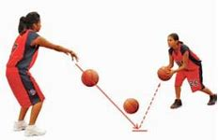
Day  4 | THURSDAY – LADDERS CHALLENGE  Create a ladder with some different items from home – teddies, socks, toys, cushions etc.  Now see how many times you can move up and down the ladder doing 2 footed jumps, hops, side jumps, star jumps and tuck jumps. | 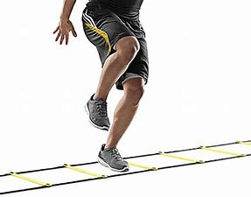
Day  5 | FRIDAY FOOTBALL – SPRINTS & KNEE UPS CHALLENGE  Your Friday task is to set out 2 markers about 10 strides away from each other if you have the space.  Place the ball at one end and then start at the opposite marker lying flat on your stomach.  Sprint between the 2 markers twice then pick up the ball and do 10 knee taps where you drop the ball onto each knee and catch it.  Repeat this 10 times, see how many knee taps you can do with out dropping the ball and keeping it under the control | 