5-Day Active Challenge
Day  1 | MONDAY – RUNNING CHALLENGE  Choose an area outside in your garden, on your drive or down at the park with an adult.  Set up a starting point and a finishing point. Use some items as markers for example: teddies, shoes, jumpers, bottles – whatever you can get.  Complete the following races between the 2 markers –  Jogging slowly, jogging faster, sprinting as fast as you can, jogging slowing backwards, jogging backwards a bit faster, sprinting on your toes backwards.  Repeat these races 5 times but record your time on each sprint race, see out of the 5 times you do it if you get faster and can beat your first score! | 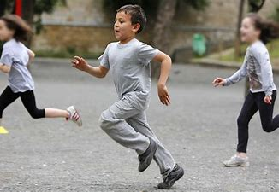
Day  2 | TUESDAY – YOGA CHALLENGE  Today have a go at this yoga class!  Follow the link on YouTube and have some fun.  Yoga for Kids! - YouTube
Day  3 | WEDNESDAY – MOVE, CATCH, PIVOT CHALLENGE  With an adult or a sibling can you run and stop when you catch the ball  Get someone to throw the ball in front of you as you run, when you catch the ball stop and pivot (swivel) on your landing foot to face your partner to throw the ball back to them.  Can you do 40 runs with 40 catches and 40 pivots!?
Day  4 | THURSDAY – WALK & RUN CHALLENGE  Can you go on a 2 mile walk today with a family member? Either at lunch time or after the school day has finished.  This week though can you do some running on your walk? Can you challenge yourself to jog for 1 minute 5 separate times on the walk?  You can do it!
Day  5 | FRIDAY FOOTBALL – CHIP CHALLENGE  Place some objects around a space – a row of teddies, a box, a row of shoes, a stool. Can you now dribble the ball with your feet (the same as last week), keeping the ball close to you and moving in and out of the lines of objects.  Once you are confident moving around the space you can dribble the ball up to one of the objects, stop the ball with the top of your foot and then chip the ball over the objects to continue dribbling the other side.  To chip the ball place the top of your foot underneath the ball and flick/lift your foot to chip the ball over the object. Follow the ball yourself and collect it the other side to the continue dribbling towards another object.  Can you chip the ball over each object in your area? Can you time yourself to see how long it takes you to chip over every obstacle? Good luck! | 