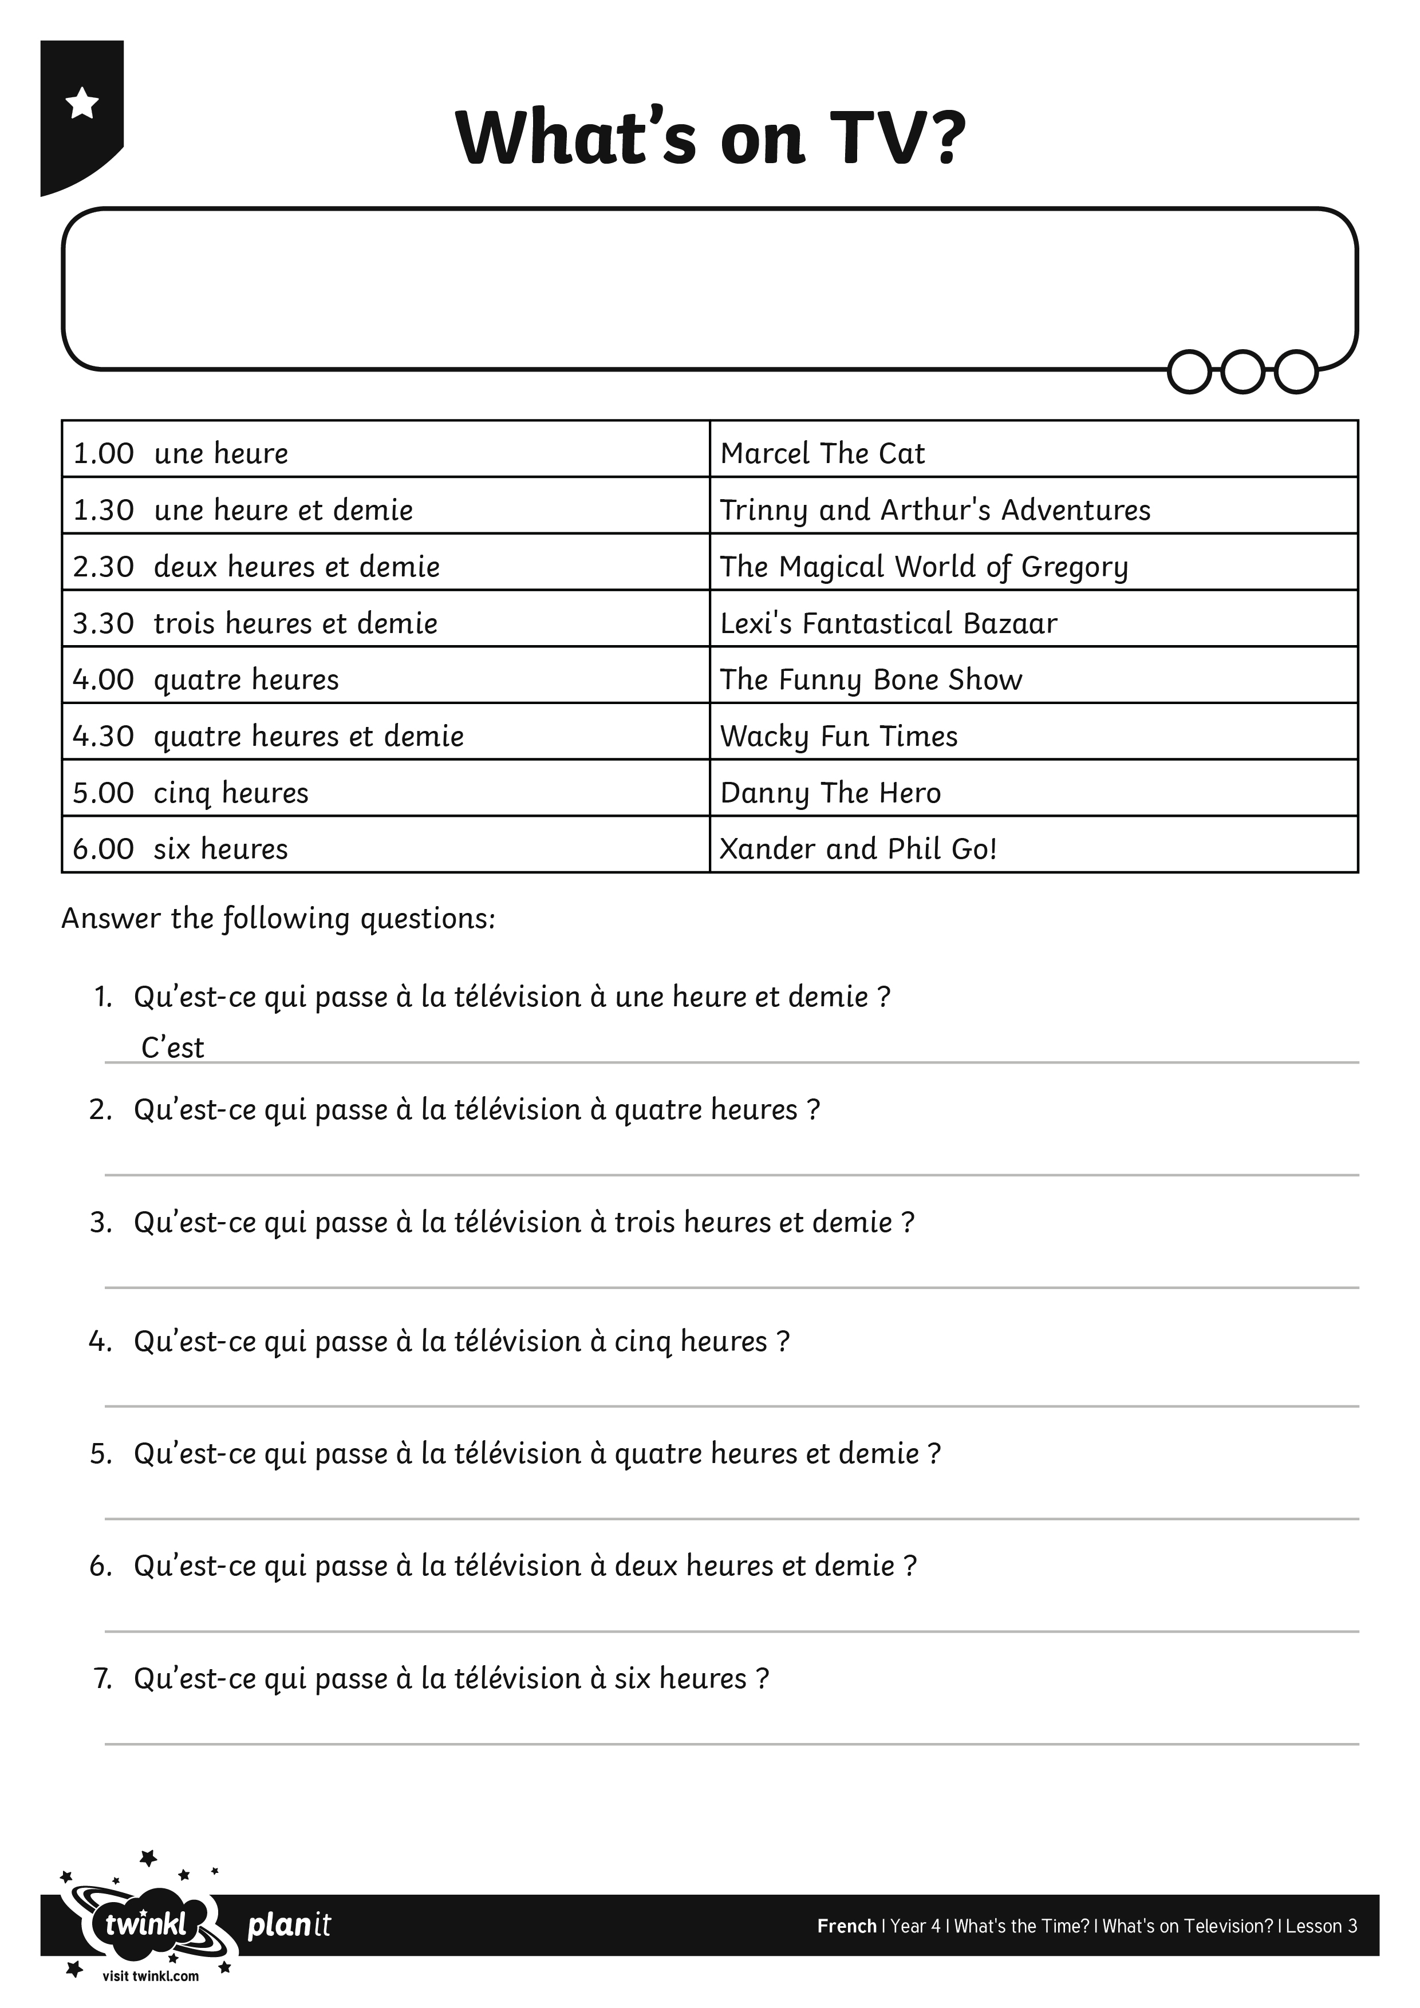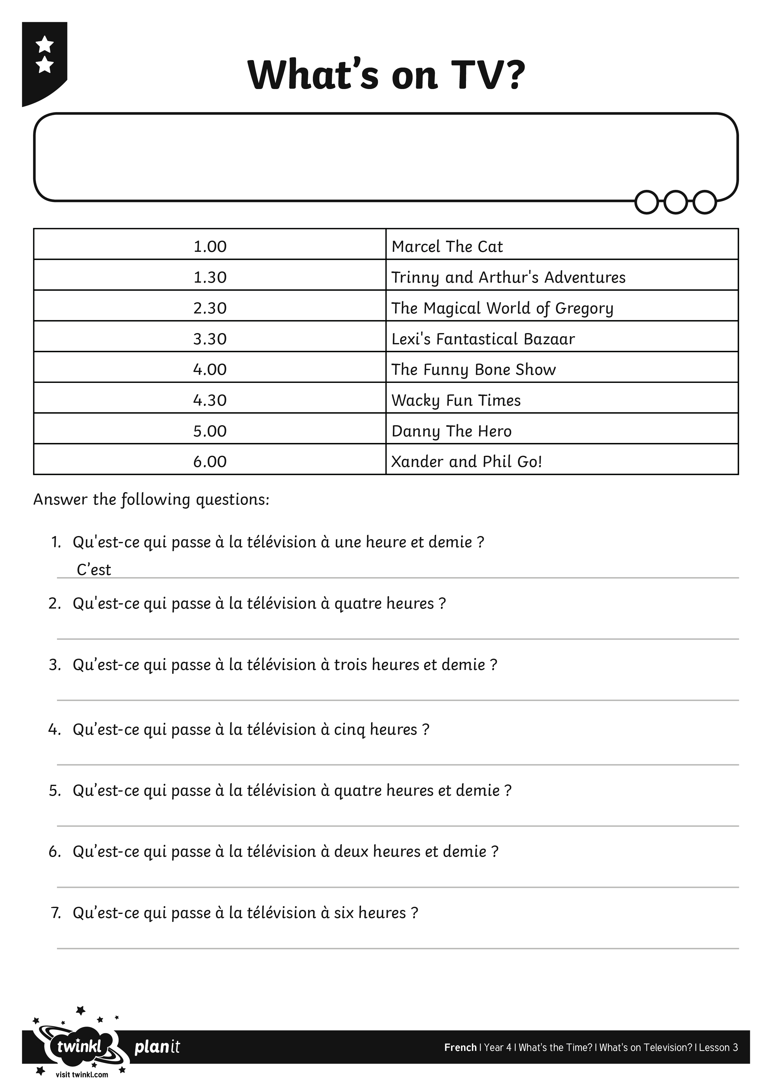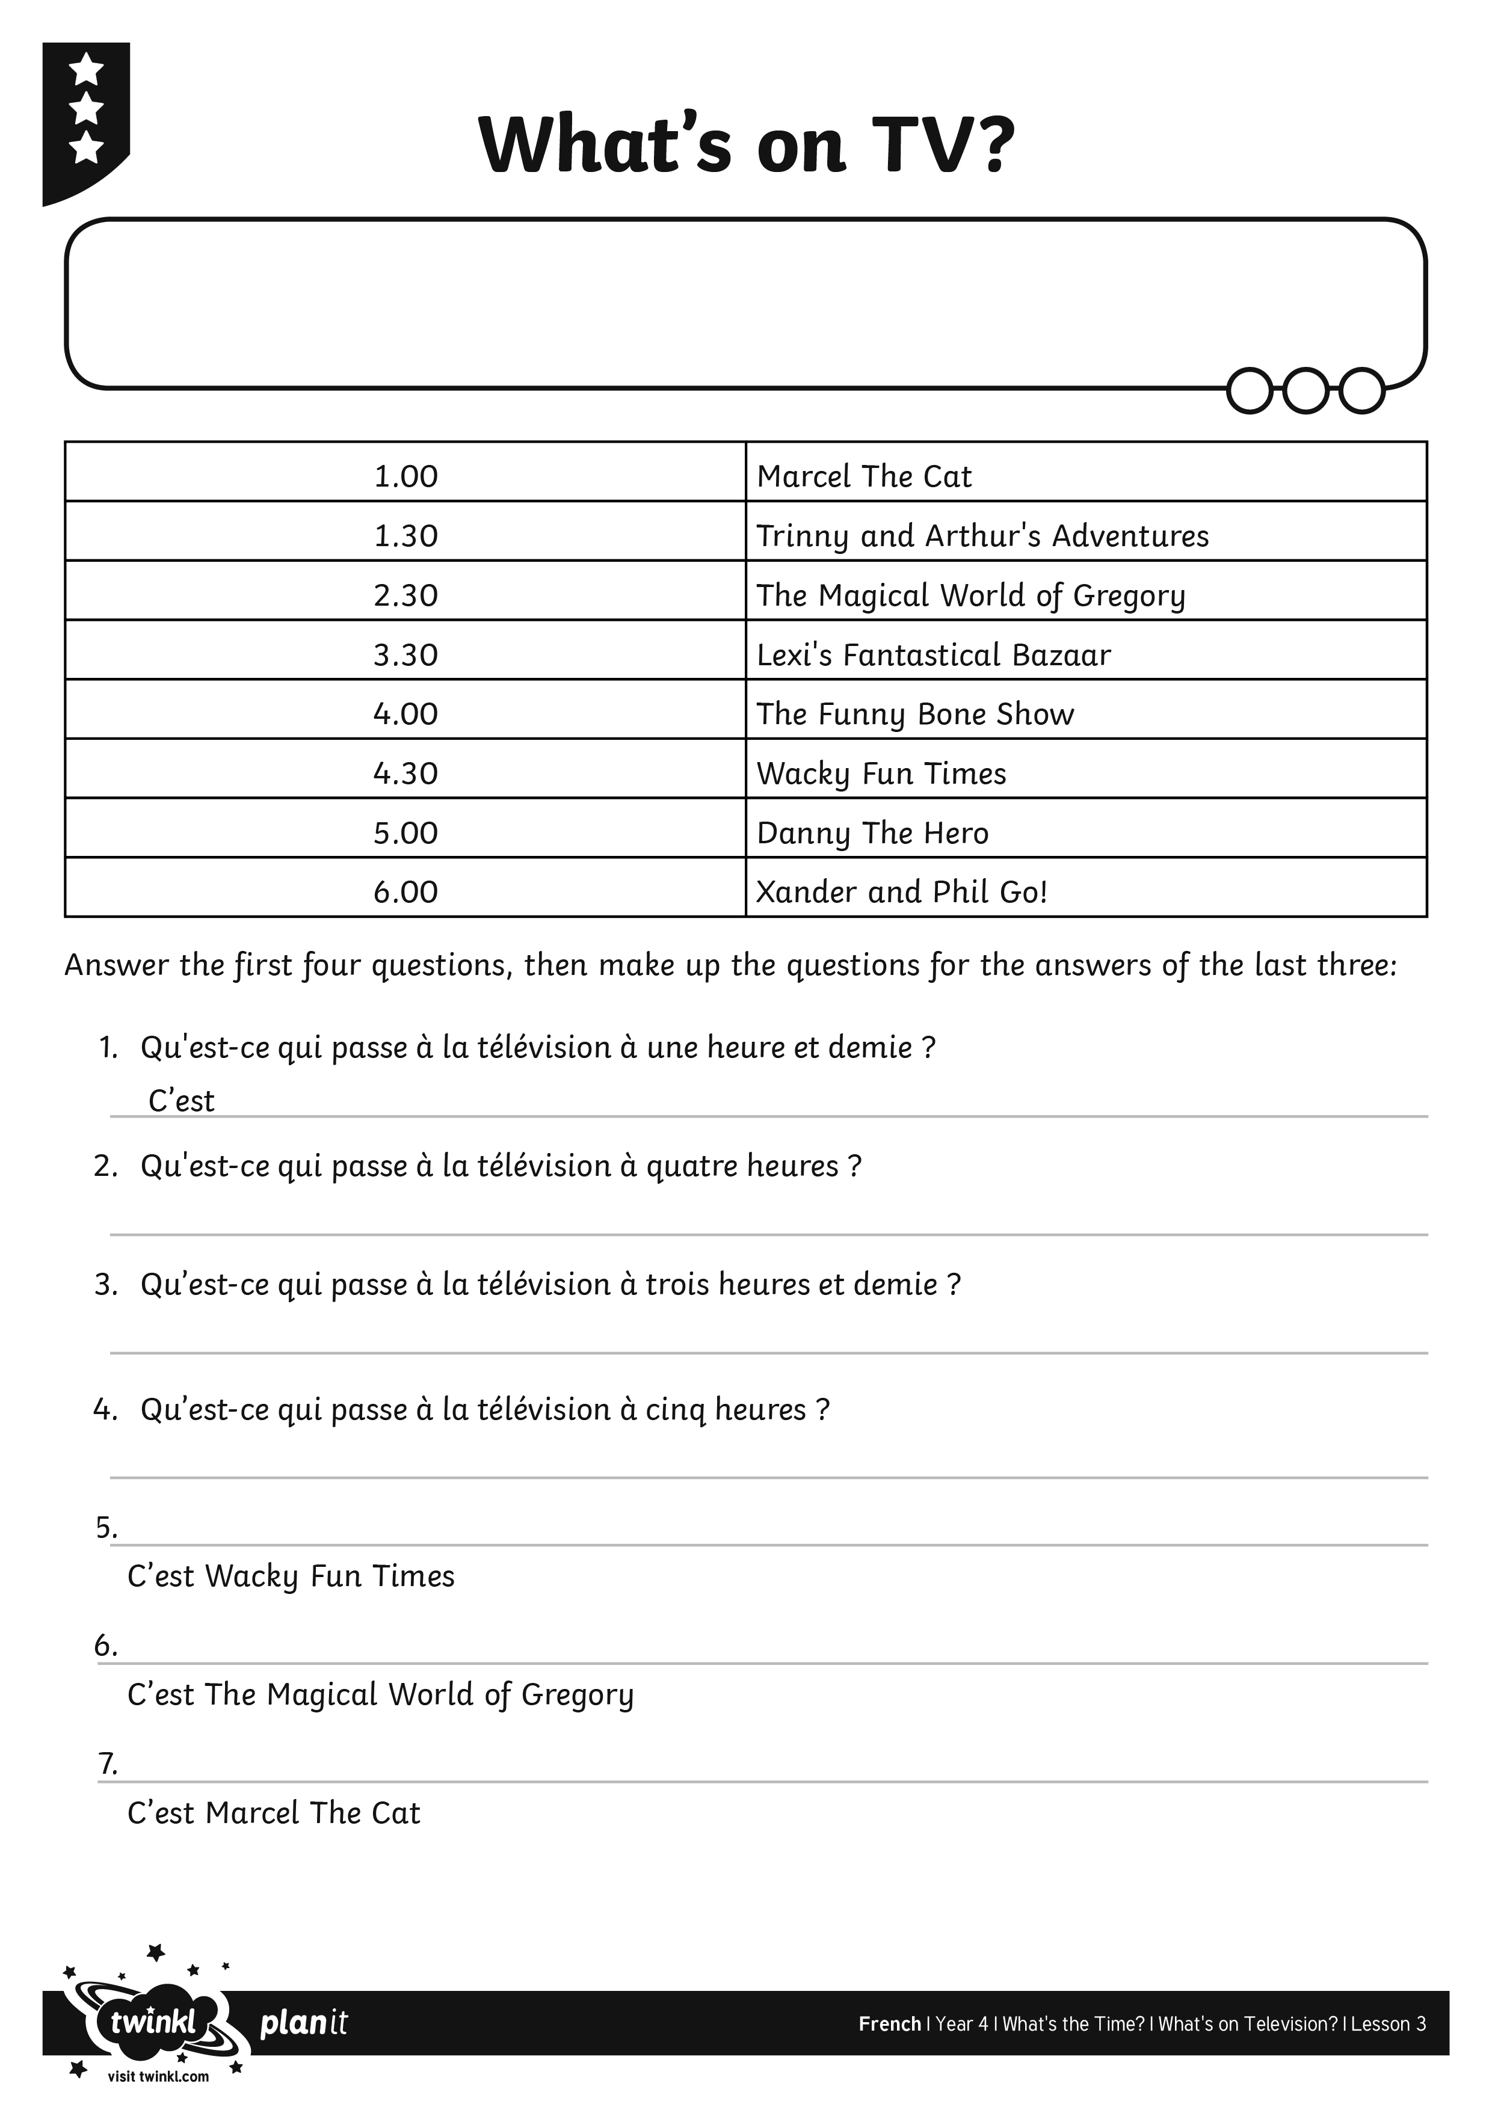
I can answer questions about a TV schedule.
I can answer questions about a TV schedule.
I can answer questions about a TV schedule.

