Suggested timetable
9-  9:30 | Exercise-  Wake yourself up by doing some exercise and promote a positive mindset. | Joe Wicks P.E lessons- Subscribe to body coach tv on YouTube  Cosmic yoga- You tube or https://www.cosmickids.com/  Just dance for kids on YouTube.
9.30- 10.00 | Phonics- Watch Mr Mc flying with phonics lessons on you tube with a notepad nearby to participate.  Join in with the phonics songs and actions. | Mr Mc phonics- Subscribe to Mr Mc on YouTube  Afterwards write a sentence with today’s sound in it.  Don’t forget capital letters and punctuation.
10-  10.30 | Reading time- Find a space to enjoy some quality reading time- Ours is just placing a furry throw on the floor with our cushions and putting a selection of books out to read and discuss. | Read a book or share a story together  Oxford owl ebooks https://www.oxfordowl.co.uk/for-home/find-a-book/library-page/ Login: dolphins! Password: Dolphins  Teach your monster to read- reading app- download from apps store for free. Or access on https://www.teachyourmonstertoread.com/  Write a book review
10.30 -11.00 | PLAYTIME!!!!
11.00- 11.30 | Maths using Power Maths textbook and practice books. | Y1- measurement Y2- Fractions
11.30- 12.00 | Literacy – Daily lessons- set on ClassDojo | Learning how to: Write statements, questions and/or exclamation sentences; Use verbs, nouns and adjectives; Improve our reading comprehension skills; make a story map; write the story in our own words.
12.00-1.00 | Lunch and PLAYTIME
PM | Online learning and topic time- A topic activity will be set weekly for you to explore and produce freely. | Spelling shed, TTRS, numbots and teach your monster to read

Literacy activities week 1 |  | Resources
Monday  Question focus | Read the Gruffalo or any other woodland story as an introduction to our forest and woodland topic.  Ask children what they know about wild animals.  Define what wild means- Definition below  What is a wild animal?  - A wild animal is an animal that is, wild.  - This means that it isn't tame and it lives on its own without any help from people.  - A wild animal finds its own food, shelter, water and all its other needs in a specific natural habitat.  - The habitat can be a field, woods, pond, wetland, prairie, park, or your garden.  - Wild animals make their home in both the city and the country.  Wildlife includes small creatures that you can only see through a microscope to animals as large as whales!  Activity: To compose 3 questions about what they would like to find out about wild animals | 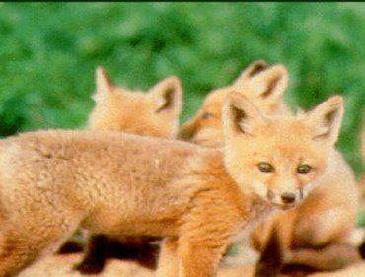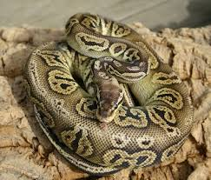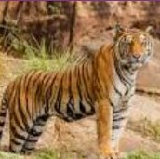
Tuesday | Sight sentences focus  Look up some images of wild animals. Choose an animal to write some descriptive sentences.  - Tiger  - Snake  - Elephant  - Meerkat  Do word collecting as demonstrated in video clip.  Activity: Use your word collector to write some descriptive sentences about your animal. Can you use adjectives? How many sentences can you write? | 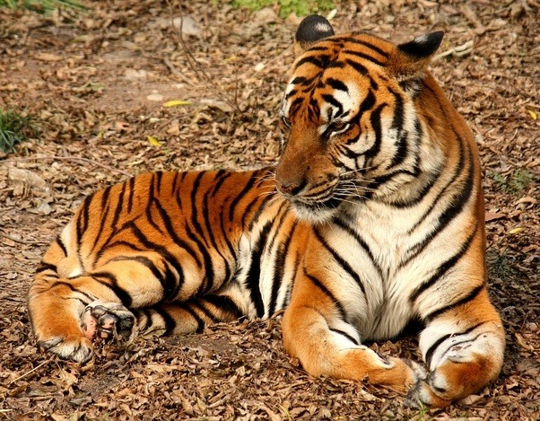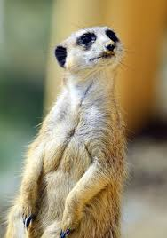  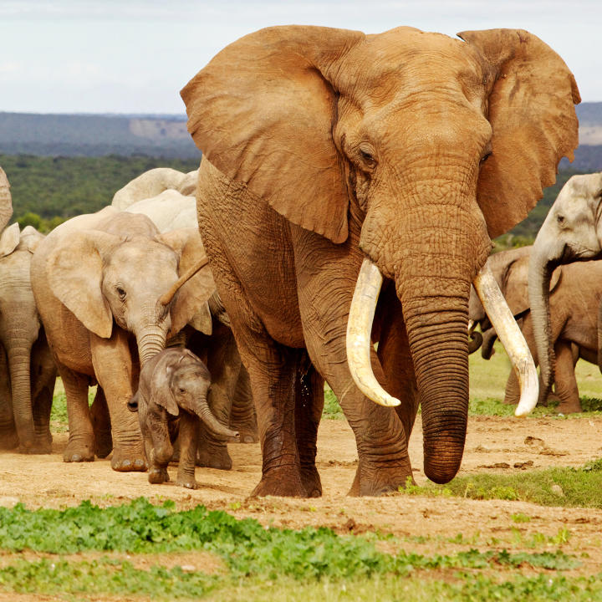
Wednesday  Question focus | Choose a wild animal, if they could speak what would you ask them?  Activity: Choose a wild animal. Draw a picture of them and ask them some questions about their lives including their habitat.
Thursday  Sight sentences | Activity: To draw a picture from a description of a creature and then write some descriptive sentences about what they have drawn.  I think this creature is…  It might live…  I would like to find out… | Description  It was the size of a frog, only round and blue. It had boggly eyes and a spiky tail and ears like a mouse. It’s wings were no bigger than daisy petals and he had four paws altogether.
Friday | Free write Friday!!!!!  Spelling test  Weekly recording of reading
Week 2
Monday | Read Bog Baby p1-5  Activity: Do you think the children should have gone to the pond?  Why do you think they weren’t allowed to go alone? | I think the children should …  They were not allowed to go alone because ...  Make your very own Bog Baby???
Tuesday | Adjectives focus  Activity: Label the Bog Baby picture template from the story.  Watch supermovers clip on adjectives.  Now go back and add adjectives.  EXT: Use your labels as a word bank to write a setting description about Bluebell Wood. | Supermovers adjectives link https://www.bbc.co.uk/teach/supermovers/ks1-english-adjectives-adverbs-with-johnny-inel/znfjbdm  Bog Baby picture template.  Example woodland setting description.  As you enter Bluebell Wood, you can see the lush grass hiding beneath the beautiful bluebells that cover the woodland. There is a mixture of white and brown intertwining trees with the most perfect, pink blossom you will ever see. And a magical pond at the end of a rickety, brown bridge where mystical pond creatures like to lark.
Wednesday | ICT/Science focus.  Discuss the animals shown on the grid with the children. Which animals live in England? Which live outside England? You could also discuss the differences between domesticated animals, which we keep for pets and wild animals.  Do they remember what ‘wild’ means?  Activity: To choose animals which live in England and research what they need to survive.  To choose animals which live outside England and research what they need to survive.  I understand that today’s literacy is a slightly longer activity so I would recommend to do three of each as a maximum but I would be happy with as little as one for each.
Thursday | Verb Focus  Read Bog Baby p 6 and 7.  Discuss what you think the Bog Baby did in or near the magic pond.  Label the picture with more verbs (doing words) about what the Bog Baby did.  Put the verbs into sentences  The Bog Baby swam under the bridge.  The Bog Baby …………………………….. | Supermovers verb tenses  https://www.bbc.co.uk/teach/supermovers/ks1-english-verb-tenses-with-karim-hacker/zr7gt39
Friday | Free write Friday!!!!!  Spelling test  Weekly recording of reading
Week 3
Monday | Comprehension focus  Read p8 and 9  Why did the Bog Baby not struggle?  Why do you think he looked surprised?  Why did the Bog Baby sit still?  Why did the Bog Baby sit still with his paws over his eyes when the girls tried to make him fly?  Why do you think he did not try to escape? | I think he did not struggle because …  I think he looked surprised because ...  I think he sat still because …  I think he did not try to escape because ...
Tuesday | Science Focus  Activity: To label the Bog Baby using nouns.  Then add adjectives to your nouns.  Label a human body.  Write a description of the differences between the human body and a Bog Baby | 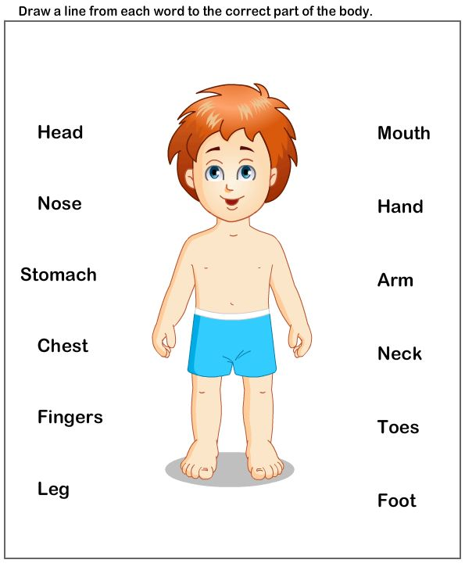
Wednesday | Science focus- Human vs Animals  Write three things that humans can do but animals can’t.  Write three things that animals can do that humans can’t.
Thursday | Comprehension focus.  Read pages 10-13  Why did the girls hide the Bog Baby?  What would you have done?  What did the girls use to make the Bog Baby habitat?  Make a list of equipment you might use to make a habitat for your Bog Baby. | Topic idea- To make a habitat for your Bog Baby.
Friday | Free write Friday!!!!!  Spelling test  Weekly recording of reading
Week 4
Monday | List focus.  Read p10-15  Activity: To make a list of the things, the girls did to look after the Bog Baby.  Comprehension questions.  Do you think they looked after him well?  Do you think the Bog Baby liked the girls?  I think the Bog Baby liked the girls because…
Tuesday | Character description.  Read p16-17  What happens to Bog Baby when he gets sick?  Activity: Draw a picture and label the things that have happened to Bog Baby when he gets sick.  Use the labels as your word bank to write a description in full sentences with capital letters and full stops about what happens to Bog Baby when he gets sick.  What do you think the girls should do now that the Bog Baby is sick?
Wednesday | Comprehension focus  Look at p 18 and discuss these questions together.  What do you think will happen next?  What do you think mum will do?  What do you think she is thinking?  Read p18-21  Activity: To write sentences about the girls and mums reactions using the questions below.  Girls reactions  Why didn’t Chrissy tell mum?  Why do you think her sister did?  Mums Reaction  Why do you think mum wasn’t angry?  How did mum explain to the girls that they could not keep the Bog Baby?  What reasons did she give?  Where do you think mum is going to take Bog Baby? | 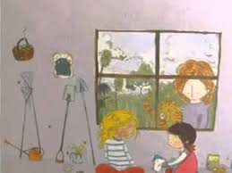
Thursday | Read p 22- end.  Discuss why you think the Bog Baby didn’t run away from the girls if it was making him sick?  Activity: To draw a picture of when Bog Baby returned to bluebell wood.  Write about what the book is trying to teach us about wild animals underneath your picture.  And answer -Do you believe in Bog Babies?
Friday | Free write Friday!!!!!  Spelling test  Weekly recording of reading
Week 5
Monday | Herbivores, Carnivores and Omnivores  Make a front cover for your woodland animal fact file.
Tuesday | Make a fact file for your first woodland animal.
Wednesday | Make a fact file for your second woodland animal.
Thursday | Make a fact file for your third woodland animal.
Friday | Free write Friday!!!!!  Spelling test  Weekly recording of reading
Week 6
Monday | To write the beginning of our very own Bog Baby story.
Tuesday | To write the middle of our very own Bog Baby story.
Wednesday | To write the ending of our very own Bog Baby story.
Thursday | To design our front cover for our story.
Friday | Free write Friday!!!!!  Spelling test  Weekly recording of reading

Maths | We will be following Power maths textbooks and workbooks for maths. Some parents have opted to buy the workbooks as it would be cheaper than printing at £1.99 from amazon.  I would suggest buying (if possible) Power maths practice book 1c (year 1) or 2c (year 2) for £1.99 and working through it together with your children.  Here is a link to demonstrate how to use the textbooks for learning and teaching at home.  http://go.pardot.com/e/749453/km4t1BF-6iS2jpPvq-index-3-t-0s/51wnx/107030801?h=iQTGLxcnwcQBoxsvPXoBr6toQe4sk_T0QQduZ171uLg
Week 1 | Year 1 | Year 2
Monday | Unit 11: Comparing weight  Practice book p 104- 106 | Unit 10: Introducing whole and parts.  Practice book p113-115
Tuesday | Unit 11: Measuring weight  Practice book p 107-109 | Unit 10: Making equal parts.  Practice book p116-118
Wednesday | Unit 11: Comparing weight using measuring  Practice book p 110-112 | Unit 10: Recognising half  Practice book p119-121
Thursday | Unit 11: Comparing Capacity.  Practice book p 113-115 | Unit 10: Finding half  Practice book p 122-124
Friday | Arithmetic sheets on class dojo
Week 2
Monday | Unit 11: Measuring capacity.  Practice book p 116- 118 | Unit 10: Recognising quarter  Practice book p 125-127
Tuesday | Unit 11: Comparing capacity using measuring.  Practice book p 119-121 | Unit 10: Finding quarter  Practice book p 128-130
Wednesday | Unit 11: Solving word problems- weight and capacity.  Practice book p122- 124  End of unit check  Practice book p125-126 | Unit 10: Unit fractions  Practice book p131- 133
Thursday | Unit 12: Counting in 10s, 5s, and 2s  Practice book p6-8 | Unit 10: Understanding other fractions.  Practice book p134- 136
Friday | Arithmetic sheets on class dojo
Week 3
Monday | Unit 12: Making equal groups  Practice book p9-11 | Unit 10: ½ and 2/4  Practice book p 137- 139
Tuesday | Unit 12: Adding equal groups  Practice book p12-14 | Unit 10: Finding ¾  Practice book p140- 142
Wednesday | Unit 12: Making Simple Arrays  Practice book p15-17 | Unit 10: Understanding a whole.  Practice book p143-145
Thursday | Unit 12: Making doubles  Practice book p18-20 | Unit 10: Understanding whole and parts.  Practice book p146- 148
Friday | Arithmetic sheet on class dojo
Week 4
Monday | Unit 12: Solving word problems- multiplication.  Practice book p 21- 23  End of unit check  Practice book p 24-25 | Unit 10: Counting in halves.  Practice book p149- 151
Tuesday | Unit 13: Making equal groups (1)  Practice book p 26-28 | Unit 10: Counting in quarters  Practice book p152-154  End of unit check  Practice book p155-156
Wednesday | Unit 13: Making equal groups (2)  Practice book p 29-31 | Unit 11: Describing movement.  Practice book p6-8
Thursday | Unit 13: Sharing equally (1)  Practice book p32-34 | Unit 11: Describing turns  Practice book p 9-11
Friday | Arithmetic sheet on class dojo
Week 5
Monday | Unit 13: Sharing equally (2)  Practice book p 35-37 | Unit 11: Describing movement and turns  Practice book p 12-14
Tuesday | Unit 13: Solving word problems- division.  Practice book p 38- 40  End of unit check  Practice book p 41- 42 | Unit 11: Making patterns and shapes  Practice book p 15-17  End of unit Check  Practice book p 18-19
Wednesday | Unit 14: Finding halves (1)  Practice book p 43- 45 | Unit 12: My way, your way  Practice book p 20 -22
Thursday | Unit 14: Finding halves (2)  Practice book p 46-48 | Unit 12: Using number facts  Practice book p 23-25
Friday | Arithmetic sheet on class dojo
Week 6
Monday | Unit 14: Finding quarters (1)  Practice book p 49- 52 | Unit 12: Using number facts and equivalence.  Practice book p26-28
Tuesday | Unit 14: Solving word problems- halves and quarters.  Practice book p 55-57  End of unit check  Practice book p58-59 | Unit 12: Using a 100 square.  Practice book p29-31
Wednesday | Unit 15: Describing turns  Practice book p60-62 | Unit 12: Getting started  Practice book p 32-34
Thursday | Unit 15: Describing positions (1)  Practice book p 63- 65 | Unit 12: Missing numbers  Practice book p 35- 37
Friday | Arithmetic sheet on class dojo  Unit 15: Describing positions (2)  Practice book p 66-68  End of unit check  Practice book p 69-70 | Arithmetic sheet on class dojo  Unit 12: Mental addition and subtraction (1)  Practice book p38- 40

Topic
Week one | Scavenger hunt | Plant a seed
Week two | To make a Bog Baby | To make a map of a local woodland area  Draw a key and identify what animals may live there
Week three | To make a habitat for your Bog Baby | leaf rubbings
Week four | Tree and leaf identification activity | Draw sketch pictures of trees, focussing on the colours of them
Week five | To make a birdhouse using a milk carton | Bake hedgehog bread
Week six | Herbivore, carnivore and omnivore activity | Make a collage using outdoor materials
 | Use google earth to explore where your favourite animals come from

