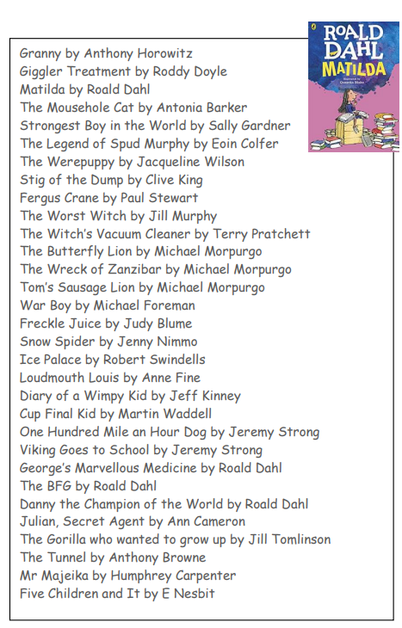 **Suggested Reading Lower Key Stage 2 (Years 3 and 4)**

