LO: How have religious teachings helped to affect somebody’s actions?

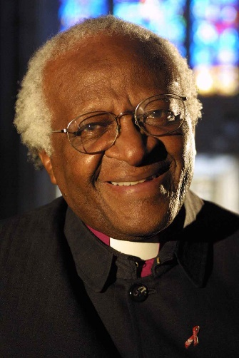
This is Desmond Tutu. Desmond Tutu was born in South Africa at a time when people with black skin were separated from people with white skin (apartheid). Black people had to go to different schools and were treated as second-class citizens – as though they weren’t as important or valued as other people.
One day, when Desmond was a child, he was out in the street walking with his mother when he saw a white priest called Trevor Huddleston show respect to his mother by tipping his hat to her. This was the first time that Desmond had seen a white man show respect to a black person and he realised that he could use his Christian faith to help bring equality between black and white people.
Task
Carry out some research on Desmond Tutu on the internet and create your own Fact Sheet about him. You can include:

1) Where and when he was born;
2) What sorts of things did he want to do with his life and why?
3) When did he win the Nobel Peace Prize and what did he win it for?
4) Any other interesting or exciting facts that you can find out about him,
5) A picture and a caption.

These websites might help you:
https://kids.kiddle.co/Desmond_Tutu
https://kids.britannica.com/kids/article/Desmond-Tutu/399993

If you or your parent/carer has any questions, please message us via Class Dojo or email us at school.
Stay safe, we miss you all.
Mrs Brear

