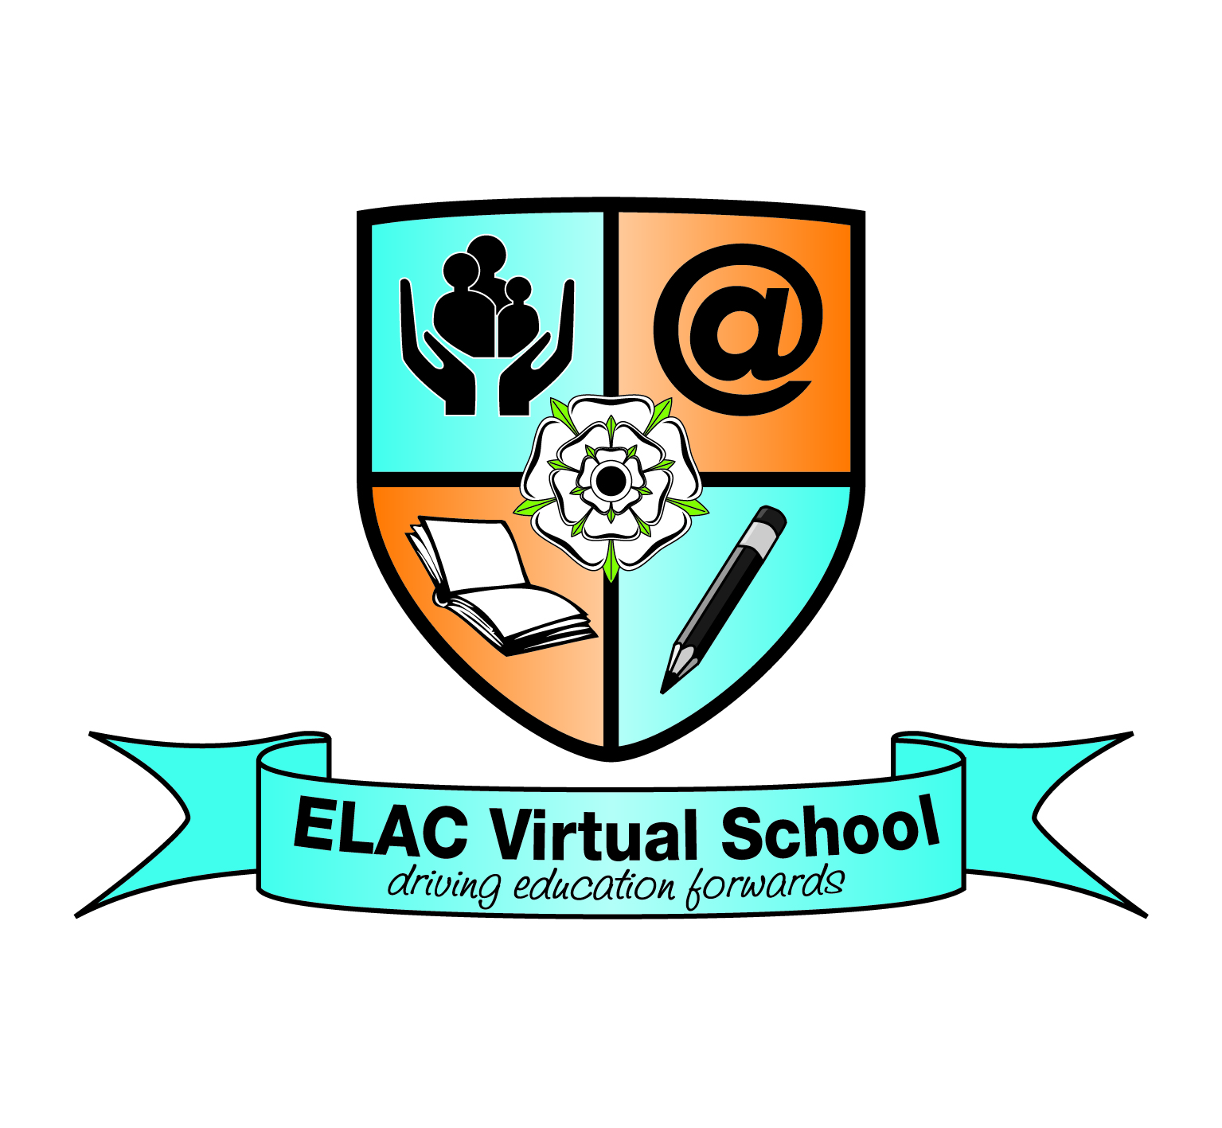

NORTH YORKSHIRE COUNTY COUNCIL

KIRK SMEATON CHURCH OF ENGLAND PRIMARY SCHOOL;
POLICY FOR LOOKED AFTER CHILDREN

Reviewed: October 2017

Purpose
To promote the educational attainment, achievement, progression and welfare of ‘Looked After Children; in the care of North Yorkshire whether they attend a North Yorkshire school or an Out-of-Authority school and for all Looked After Children in the care of other local authorities who attend North Yorkshire County Council schools. The local authority has a statutory role to play for all children in its care and acts as a Corporate Parent.

Rationale
Looked After Children (LAC) are one of the most vulnerable groups in society. The majority of LAC have suffered a disrupted childhood and experienced adverse events. It is nationally recognised that there is considerable educational under-achievement when compared to their peers. LAC often achieve poor exam success rates in comparison with the general population. Fewer Looked After Children progress to Higher Education or follow progression pathways that will lead to future economic success and well-being.

Legal Framework
Under the Children Act 1989, a child is looked after by a local authority if he or she is in their care or provided with accommodation for more than 24 hours by the authority. They fall into four main groups:

- Children who are accommodated under a voluntary agreement with their parents (Section 20)

- Children who are the subjects of emergency orders for their protection (Sections 44 and 46)

- Children who are the subjects of a care order (Section 31) or interim care order (Section 38)

- Children who are compulsorily accommodated – this includes children remanded to the local authority or subject to a criminal justice supervision order with a residence requirement (Section 21)

Children who are cared for on a voluntary basis are “accommodated” by the local authority under Section 20 of the Children Act – they may live in foster care, in a Children’s Home or in a residential school.

The term “in care” refers only to children who are subject to a care order by the courts under Section 31 of the Children Act 1989 – they may live with foster carers, in a Children’s Home, in a residential school, with relatives or with parents under supervision.

For all children who receive more than 75 days of ‘short breaks’ in every 12 months LAC status applies and an independent Reviewing Officer is appointed. As the care arranged is not continuous academic attainment does not have to be reported in the same way to the DfE.

All these groups are said to be “Looked After Children” (LAC). They may be looked after by our local authority or may be in the care of another authority but living in ours.

- The Name of the Designated Teacher for Looked After Children is:
Mrs Hannah Cuddy and Ms Sally Wolff

b) The Role of the Designated Teacher for Looked After Children

Within School:
- To ensure that all staff, both teaching and non-teaching, have an understanding of the difficulties and educational disadvantage faced by Looked After Children and that staff understand the need for positive systems of support to overcome them;

- To inform members of staff of the general educational needs of Looked After Children, and to promote the involvement of these children in school homework clubs, extra curricular activities, home reading schemes, school councils, etc;
- To act as an advocate for Looked After Children;
- To develop and monitor systems for liaising with carers, social workers, health professionals and the North Yorkshire ELAC Virtual School;
- To hold a supervisory brief for all Looked After Children, e.g. to ensure all relevant education and care information is available to school staff and carer(s), and that this information is kept up-to-date. It is important to be aware that some children in care do not want all adults or peers to know about their accommodation or care status;
- To monitor the educational progress, attainment and attendance of Looked After Children.
- To include targets on the performance of LAC within the School Development Plan.
- To intervene if there is evidence of individual under-achievement, absence from school or internal truancy;
- To celebrate the success of all Looked After Children.

Work with Individual Looked After Children
- To enable the child to make a contribution to the educational aspects of their care plan;
- To help ensure that each pupil has a Personal Education Plan (the PEP should be initiated by the young person’s social worker from the Authority responsible for them). The PEP sets out appropriate targets and support available;
- Ensure that the Pupil Premium which applies to LAC who have been in care 6 months and over is targeted at improving attainment and achievements. A summary of the impact of the Pupil Premium should be included on the school website.
- To consult with the child or young person and ensure they have an appropriate adult who will attend school events e.g. parents’ evenings; sports; drama events to provide support and encouragement.

Liaison with other Partners
- To liaise with the member of staff responsible for monitoring children on the Child Protection Register, ensuring all LAC in school are safeguarded;
- To help an Independent Reviewing Officer (IRO) co-ordinate education and Looked After Children review meetings, so that the Personal Education Plan can inform the child’s Care Plan;
- To attend, arrange for someone else to attend, or to contribute in other ways to Looked After Children at care planning meetings and PEP meetings;
- To be the named contact for colleagues in the North Yorkshire ELAC Virtual School and other local authorities as appropriate;
- To ensure the speedy transfer of information and school records between agencies and other schools;
- To ensure the school admits Looked After Children in line with the Admissions Code of Practice; schools should admit all LAC separate to ‘In Year Fair Access Protocols’.
- To ensure that the Head Teacher considers a range of strategies before exclusion for a LAC, which should be a last resort.

Training
- To develop a knowledge of Vulnerable Children/Education inclusion procedures by attending training events organised by the Local Authority and other providers;
- To attend training for Designated Teachers as appropriate;
- To cascade training to school staff as appropriate.

- The name of a Governor with special responsibility for Looked After Children: Ms Sally Wolff

- The role of that Governor: Ms Sally Wolff
  - The named governor will report to the Governing Body on an annual basis (unless it will be easy to identify individual children whereby work on behalf of all vulnerable groups may be more appropriate):

    - Areas that may be reported;
    - A comparison of test scores for LAC as a discrete group, compared with the attainment and progress of other pupils;
    - The attendance of pupils as a discrete group, compared with other pupils;
    - The level of fixed term/permanent exclusions; and
    - Pupil destinations.
- The named governor should be satisfied that the school’s policies and procedure ensure that looked-after pupils have equal access to:
- The national curriculum;
- Public examinations;
- Careers guidance;
- Additional educational support;
- Extra-curricular activities;
- Work experience

- Responsibility for Looked After Children in School
It is important that all teaching staff who are in contact with the child or young person are aware that he/she is being looked after by the Local Authority. The responsibility for the transfer of this information should be that of the Head Teacher and/or the Designated Teacher for Looked After Children.
It is appropriate for Learning Support Assistants to have knowledge that the young person is being looked-after only when they are directly involved in the teaching of the young person or the direct supervision of them during breaks and lunch times.
In the absence of the usual class teacher, some information regarding the child’s circumstances should be shared with the teacher covering the class. The extent of this sharing should be determined by the Head Teacher or the Designated Teacher for Looked After Children.

- Admission Arrangements
On admission, records (including the PEP) will be requested from the pupil’s previous school and a meeting will be held with carer/parent/social worker. A date will be agreed for a new Personal Education Plan within 20 school days of a new LAC being admitted. An appropriate school admissions meeting will take place. In some cases it may be helpful to provide a mentor from within or external to the school community.

- Involving the Young Person
It is important that a young person is aware that information is being recorded regarding their personal circumstances. How this is shared with them clearly depends on their age and understanding. It is good practice to consult and share with a young person appropriate records that are held by school and the local authority. The explanation should emphasise that the school, the social worker, and their carer(s) are working together to help them achieve in school.

- Communication with Other Agencies
Kirk Smeaton CE Priamary School ensures that a copy of all reports (eg end of year reports) should be forwarded to the young person’s Social Worker in addition to the Foster Carer or Residential Social Worker. It should be agreed at the PEP meeting what information parents will receive, this needs to be in line with the legal framework. A Social Worker will be able to advise on correspondence with parents and approaches to normalise consent for routine school activities.

- Assessment, Monitoring and Review Procedures
Each looked-after pupil will have a Care Plan that will include a Personal Education Plan (PEP) that the Social Worker takes a lead in developing. This will identify, success, specific areas of concern and include achievable targets. The PEP developed by North Yorkshire County Council is age group specific. Areas for consideration will include:
- Attendance;
- Achievement Record (academic or otherwise);
- Behaviour;
- Homework;
- Involvement in Extra Curricular Activities;
- Special needs (if any);
- Development needs (short and long-term development of skills, knowledge or subject areas and experiences); and
- Long-term plans and aspirations (targets including progress, career plans and aspirations).
The PEP will be updated at least every six months, as part of the Statutory Reviewing process carried out by Children’s Social Care. The PEP will be stored on the local authority ICS case management system and circulated to all key parties who attended the PEP meeting.

North Yorkshire County Council will:
- Provide a Virtual Head Teacher who has responsibility for championing the education of Looked After Children
- Provide a specialist team to provide targeted support for Looked After Children as part of the North Yorkshire ELAC Virtual School
- Lead the drive to improve educational and social care standards for Looked After Children
- Ensure that the education for this group of pupils is as good as that provided for every other pupil
- Ensure that Looked After Children receive a full-time education in a mainstream setting wherever possible
- Ensure that every Looked After Child has a school to go to within 20 school days of coming into care or of coming to North Yorkshire from another authority
- Make sure that each Looked After Child has a PEP according to national guidance
- Ensure that every school has a Designated Teacher for Looked After Children and that these teachers receive appropriate information, support and training
- Liaise with local Collaborative panels, Enhanced Mainstream Primary Schools and Pupil Referral Service over alternative educational provision
- Ensure that appropriate support is provided whenever possible
- Work with others to provide smooth transitions at the end of the Foundation Stage and Key Stages 1, 2, 3 and 4
- Provide advice and guidance for those LAC and Care Leavers in Further and Higher Education
- Be vigilant and proactive in identifying additional needs and the special education needs of Looked After Children and work collaboratively with schools, other services and agencies to meet those needs
- Hold events that celebrate the achievement of LAC
- Consider the views of all LAC through a variety of strategies including the Young Person’s Council

Local Authority contact details for the Education of Looked After Children are:
North Yorkshire ELAC Virtual School
North Yorkshire County Council
County Hall
Northallerton
North Yorkshire
DL7 8AE
The generic phone number for all enquires is 0845 034 9589
FAX: 01609 797141
EMAIL: elac@northyorks.gov.uk

North Yorkshire ELAC Virtual School structure and roles
Head Teacher ELAC Virtual School 01609 532169

Children’s Social Care LAC Team Managers:

Group Manager CSC LAC 01609 534117
Team Manager LAC West 01609 533570
Team Manager LAC East 01609 534131
Team Manager LAC North 01609 533094
Team Manager LAC South 01609 535639

