Date | Morning session 1 | Exercise break | Morning session 2 | Afternoon session | Exercise break | Relax
Mon  8th June | English: Independent Writing.  Write for pleasure. Ideas that you could write about are:  - Complete the Happiness Journal (see attached for ideas)  - Diary of your week.  - What you would like to do once lockdown is over;  - Write your own story about anything.  Remember to use capital letters, full stops and paragraphs and see if you can include your own targets in there. | Do an Oti Mabuse dance class.  https://www.youtube.com/channel/UC58aowNEXHHnflR_5YTtP4g | Maths:  Mental arithmetic  Complete the mental maths test attached. The answer sheet is at the end.  Year 3 Test  Year 4 Test  Year 5 test – for those wanting a challenge. | Science: Access this week’s science online on Seneca or do a home learning science project. |  | Read a book or listen to an audio book story.
Tue  9th June | English: Grammar and punctuation  Page 33 of the English Curriculum workbook.  Year 3: Using the past tense.  Year 4: Using paired adjectives.  The answers will be posted on dojo so keep an eye out for them. | Do a Yoga session on Cosmic kids.  https://www.youtube.com/user/CosmicKidsYoga | Maths:  Page 4 of the Maths workbook  Year 3: Subtracting numbers with 2 digits.  Year 4: Use known facts to multiply and divide.  Or  Divide whole numbers with up to 3 digits.  The answers will be posted on Dojo so keep an eye out for them. | Art/DT:  Photography challenge.  Ask a parent to use a device with a camera. Think about household objects or garden items that could be photographed interestingly.  You could:  Add a filter/change to black and white.  Crop the picture to change the focus.  Have fun and surprise us! |  | Read a book or listen to an audio book story.
Wed  10th June | English: Reading comprehension  Year 3: Page 22 of the English curriculum workbook.  Year 4: Page 22 of the English curriculum workbook.  Read the text carefully then answer the questions.  The answers will be posted on Dojo so keep an eye out for them. | Try a Joe wicks session  https://www.youtube.com/channel/UCAxW1XT0iEJo0TYlRfn6rYQ | Maths:  Page 5 of the Maths workbook  Year 3:Recall and use multiplication and division facts.  Year 4: Multiply 2 digit by 1 digit numbers  OR  Add fractions with mixed numbers.  The answers will be posted on Dojo so keep an eye out for them. | Topic: History  Access this week’s assignment on Seneca. |  | Read a book or listen to an audio book story.
Thurs  11th June | English: Grammar and punctuation  Page 34 of the English Curriculum workbook.  Year 3: Using speech marks.  Year 4:.Using paired adjectives.  The answers for Year 4 will be posted on Dojo so keep an eye out for them. | Do some dancing with GoNoodle  https://www.youtube.com/channel/UC2YBT7HYqCbbvzu3kKZ3wnw | Maths:  Page 6 of the Maths Arithmetic workbook  Year 3: Multiply 2 digit by 1 digit numbers  Year 4: Divide two digits by 1 digit.  Or  Subtracting fractions with mixed numbers.  The answers will be posted on Dojo so keep an eye out for them. | RE: To find out about the festival of Purim.  Read the story and information about the festival of Purim in the slides.  Task: create your own mask representing one of the main characters in the story (Esther, Mordecai,  King Xerxes and Haman). Use the template provided, use a paper plate or draw round a plate onto some cardboard (I like to use empty cereal boxes or cardboard boxes at home).  You can use any materials that you can find at home to decorate your mask (for example fabric, tissue paper, wool, coloured paper, cereal, pasta etc.) to create or add hair, crowns, facial features, etc. to your mask.  Once you have finished, send us a photo so we can have a look at your masks. |  | Read a book or listen to an audio book story.
Friday  12th June | English: SPaG  Spelling shed  SPaG.com – Y3 or Y4 Grammar (C) | Try a Joe wicks session  https://www.youtube.com/channel/UCAxW1XT0iEJo0TYlRfn6rYQ | Maths:  Numbots  Timestables Rockstars | Ethos/Wellbeing:  Look after yourself- take some time out to read this and maybe have a go at few.  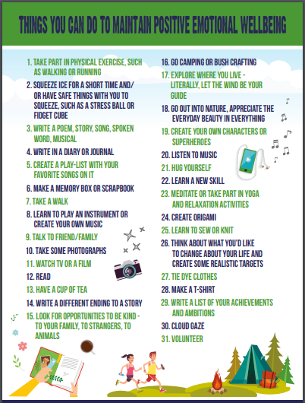 |  | Read a book or listen to an audio book story.
WEEKEND!!!! Play, read, laugh and squeeze every last drop of fun out of your weekend.

