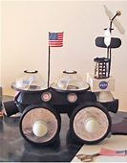

Your task today is to design and make a moon buggy.
Look up some ideas on the internet.
You can use anything around the house to make it. If possible it needs to move.
Send a picture to me once it is finished, as I’d love to see your completed Moon Buggy.

