
Marking Policy
Reviewed: Jan 25

Why do we mark work?
- to value the children’s work
- to show that it has been monitored, evaluated and reviewed
- to encourage good standards and take the child’s learning forward
- to support children by showing how their work can be improved
- to highlight a repetitive problem
- practical activities such as PE, art, D&T, reading etc. feedback will be verbal positive and instant.

How we mark
- Work should be marked with the child or as soon as possible and where possible within the lesson. Marking needs to be smart and impacting, symbols are often used for speed and understanding.
- Children can be helped to assess their own work evaluating their own and others progress through peer marking.
- If the child has made a large number of errors they do not all need to be corrected. Common faults, spellings, grammar and punctuation should be picked out for practice. A sentence may be highlighted to be redrafted. Up to 3 spellings can be written below or the teacher can highlight the spelling error using sp in the margin. If the child is able they would be expected to use a dictionary or the internet to check and change spellings.
- Whenever possible children are encouraged to spend time looking at where the teachers have suggested improvements and either practice or correct the mistake. Teachers will build review time into their sessions.
- Homework can be given dojos to award effort and progress.

Letter/Number reversals and basic spelling mistakes – children are expected to know days of the week, months of the year and reversals of numbers and letters where these are incorrect, children should be made to edit immediately and progress should be seen instantly.

Learning objectives and date
The short date to be written in Maths and the long date to be written for Literacy on the top line, leave a line then the learning outcome or task number.

Assessment for Learning
From foundation onwards, children are encouraged in some situations to self-mark, under the teacher’s guidance, for instant feedback and to develop the beginning of self-assessment. Children are encouraged to use check lists and learning walls for self review before handing in completed work. Teachers including general teaching assistants can mark work.
Purple to perfect- children edit or highlight any corrections they have made with the purple pen.
Green pen- all adults use green pen to mark work
Pink pen- for peer marking

Symbols
^ | A phrase or word has been missed out.
x | If a child makes a mistakes, the word or sentences should be added in brackets and a cross above.
*Or . | Highlighting grammar or sentence structure. Dot an incorrect answer in Maths.
✓ | Correct
CL | Capital Letters
P | Punctuation
// | Paragraphs
SP | Spelling needs correcting
S | Supported work
 | Next steps
✓✓ | Something impressive (wow)
VF | Verbal feedback
 | Squiggly line to highlight an error
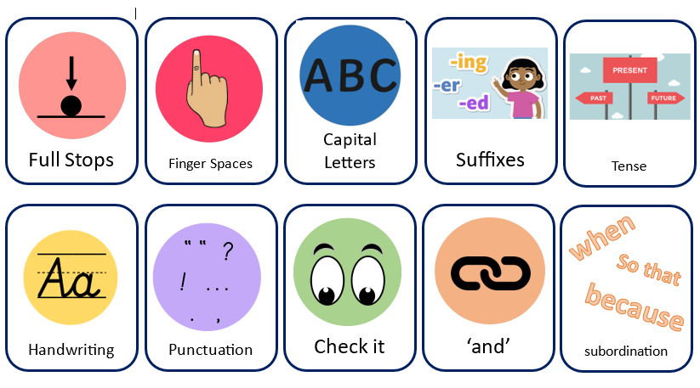 | These stickers are used as the pathway to write scheme, often they are ticked off to show progress and next steps.

