How to Perform Wudu Answers

Steps 1
1.
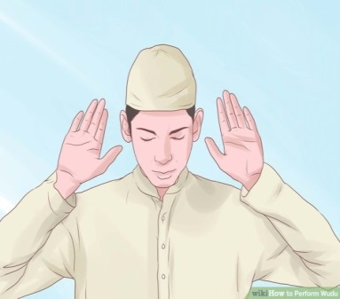
Make niyyah (Intention) to perform washing.
2.
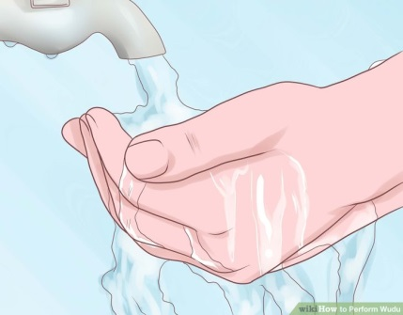
Wash your hands
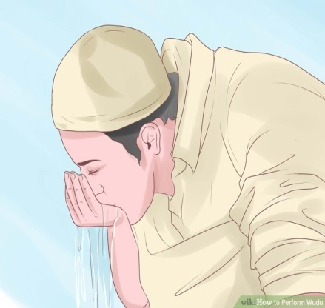3 Take water into your mouth. <
< 4. Inhale water into your nose.
< 5 Wash your face.
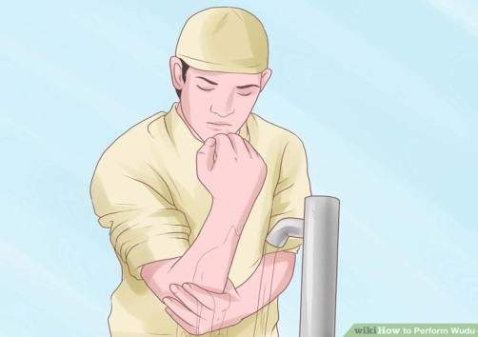 6.. Wash your lower arms from wrists to elbows.

7.Clean your head.

8.Wipe your ears inside and out.
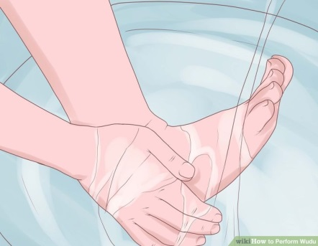 9.Wash each of your feet.
10. While pointing the right index finger to the sky, recite a brief prayer of witness.

How to
Mentally Prepare Soldiers for the Stress of Warfare

How to
Make Islam Part of Your Life

How to
Perform Salah

How to
Create a Garden with Persian, Arabic or Islamic Influences

How to
Convert a Muslim to Christianity

How to
Find Truth According to Islam

How to
Become a Better Muslim Male

How to
Dodge a Punch

How to
Practice Guitar with a Metronome

How to
Make a Tic Tac Toe Game from a Cutting Board

How to
Prevent Hair from Knotting

