How to Perform Wudu
Wudu, or ablution, is both a traditional ritual and a practical means by which Muslims seek to maintain good physical and spiritual hygiene. Traditionally, Wudu refers to the mental preparation and physical cleanliness of Muslims for the Salat (prayer), one of the Five Pillars of Islam.

Steps
Look at the pictures below. Cut them out and put them in the order of the WUDU then look at the sentences below. Match them up with the pictures in the correct order.
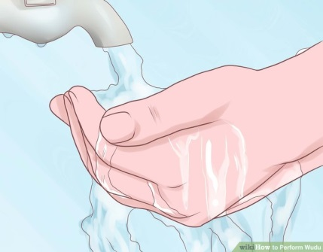
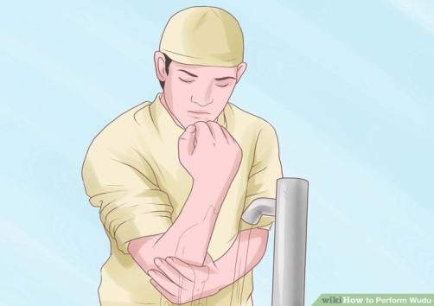
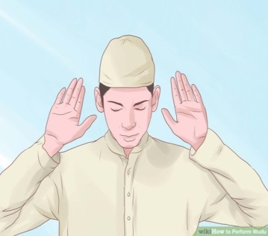
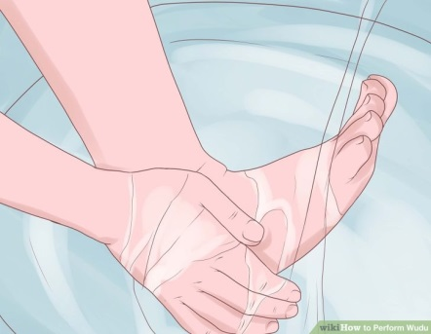
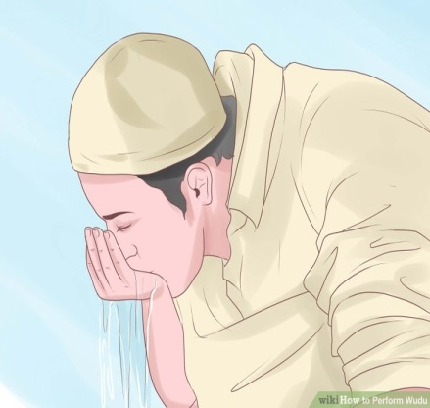

Take water into your mouth.
Wash your face.
Inhale water into your nose.s Part of Your Life
Wash each of your feet.
Wash your lower arms from wrists to elbows
How to
Wipe your ears inside and out. Perform Salah
Make niyyah (Intention) to perform washing.
Wash your hands
While pointing the right index finger to the sky, recite a brief prayer of witness.
Clean your head.

How to
Create a Garden with Persian, Arabic or Islamic Influences

How to
Convert a Muslim to Christianity

How to
Find Truth According to Islam

How to
Become a Better Muslim Male

How to
Dodge a Punch

How to
Practice Guitar with a Metronome

How to
Make a Tic Tac Toe Game from a Cutting Board

How to
Prevent Hair from Knotting

