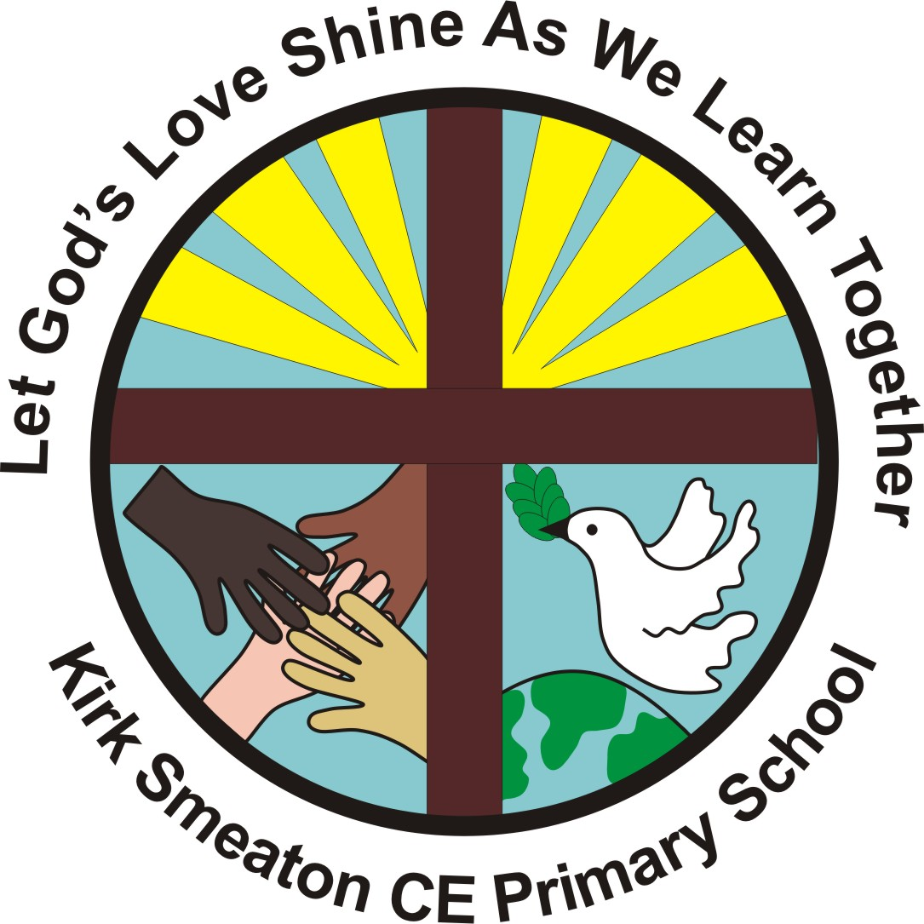
Kirk Smeaton CE (VC) Primary School
Handwriting Policy

Reviewed Oct 24

Philosophy
Handwriting is concerned with individual expression and the conveying of meaning through fluent composition. The explicit, systematic teaching of key skills ensures that handwriting becomes an automatic process which frees pupils to focus on the content of their writing. In order for this to occur, handwriting is taught in ways that enhance fluency, legibility, purposefulness and the opportunity for creative expression.

Handwriting is taught regularly, we set high expectations for all children to ensure they show consistently high standards in all their writing.

All pupils, left or right handed should support their writing paper with the non writing hand at all times. We use guidelines to support handwriting in the first instance. All short letters sit within the two solid lines, all tall letters sit on the bottom solid line and reach the highest broken line and all low letters sit on the bottom solid line and descend to the bottom broken line.

- - - - - - - - - - - - - - - - - - - - - - - - - -
____________________________
____________________________

- - - - - - - - - - - - - - - - - - - - - - - - - -

When the child is ready we move on to no guidelines and just a line.
I went to the shops.

Early writing
The emphasis at this stage is with movement. Letter formation (starting at the correct entry point and then moving in the correct direction) learned at this early stage becomes automatic and has a profound influence on later fluency and legibility. To aid movement, close attention is given to pencil grip, correct posture, the positioning of the paper and the organisation of the writing space. The Reception Teacher and Teaching Assistant are vigilant to ensure that bad habits and incorrect letter formation do not become ingrained and that the specific needs of left-handed pupils and those with special educational needs are met.
Pupils are given the opportunity to experiment with a range of writing materials and implements; a multi-sensory approach is used to help pupils feel the movement in the hand.
Pupils will physically develop the movements of letter shapes using gross motor skills with ribbons, scarves, chunky chalks, sand, paint, IWB and large chalk/white boards. Pupils will use a range of tools to develop fine motor skills e.g. wax crayons, chunky pencils, marker pens, shaving foam, finger paints and brushes. Pupils will practise manipulative skills with Lego and other small construction, threading beads and cards, sewing, pegs and pegboard patterns, play dough, small world and jigsaws. Children in the Reception class are exposed to a wide variety of print within their environment, including the precursive alphabet from the school handwriting scheme. This precursive hand will be introduced into the writing of individual children at a developmentally appropriate time within the phonics sessions.
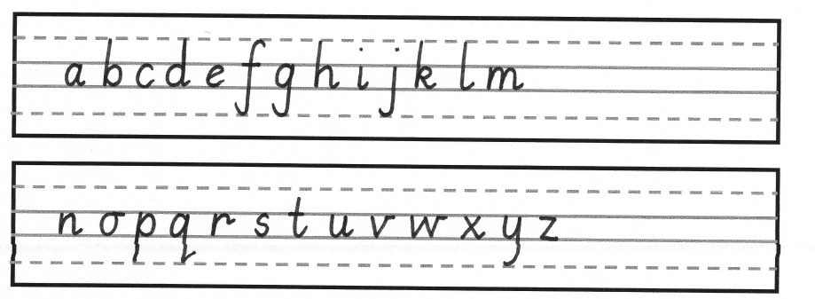

Developing writing (Y1 onwards)
At this stage we hope to see efficient pencil grip and all letters are correctly formed and all descenders and ascenders are clearly written, we hope that this is achieved by the end of Reception, beginning of Year 1.
We practise writing daily and ensure that children have scaffolds and support for an adult to develop into a fluent and legible text.

Pupils are taught the correct joins, and exercises are linked to blends, spelling patterns and high frequency words/tricky words. It is expected that by the end of Y2 the majority of pupils are able to join their writing in a clear and legible way.
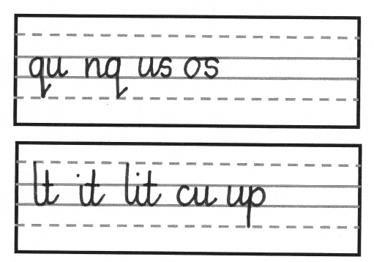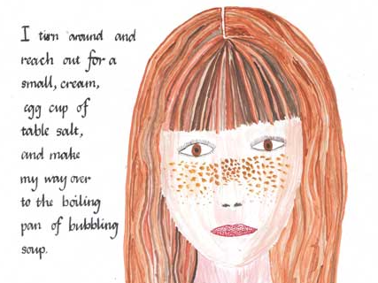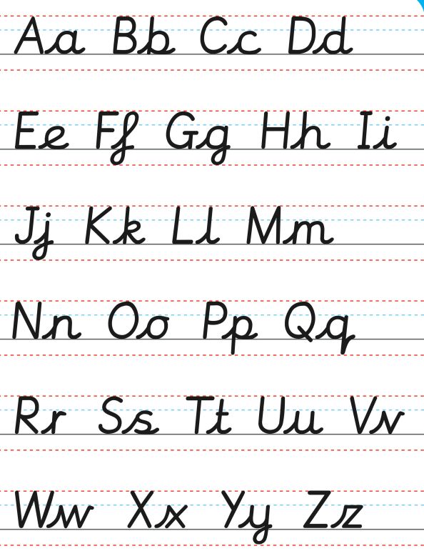

Secure handwriting
Pupils consolidate their use of the handwriting joins taught in Year Two, ensuring consistency in size, proportion and spacing of letters. Handwriting speed, fluency and legibility are built up through practice.
When a smooth, flowing, functional style becomes habitual, speed will increase without effort and without loss of legibility. When a child is able to do all of these things, we then award a handwriting licence, where they can write with a pen.

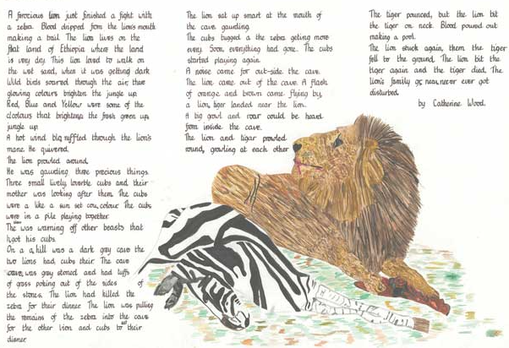

Line guides used in school and expectations throughout the years

EYFS- Term 1 and 2 (3.3cm from top dotted line to bottom dotted line.
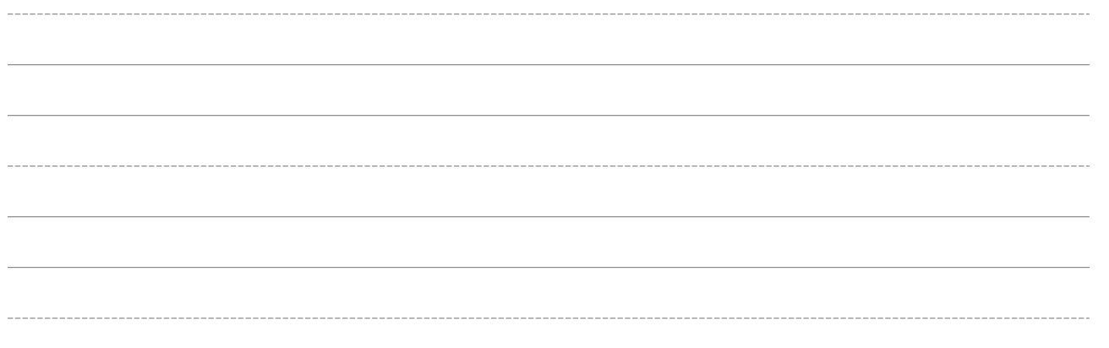

EYFS- Term 3 and Y1 (2.5cm from top dotted line to bottom dotted line)

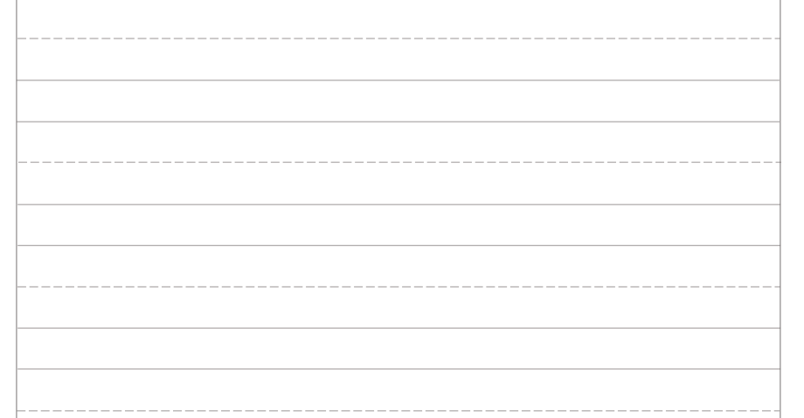
Y1- Term 3 and Y2 (2cm from top dotted line to bottom dotted line)
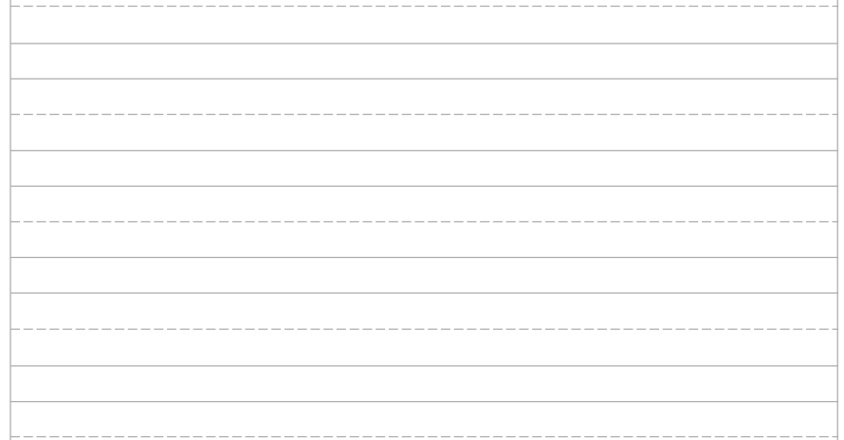
Y2 Term 2 and 3 and Y3 (1.5cm from top dotted line to bottom dotted line)

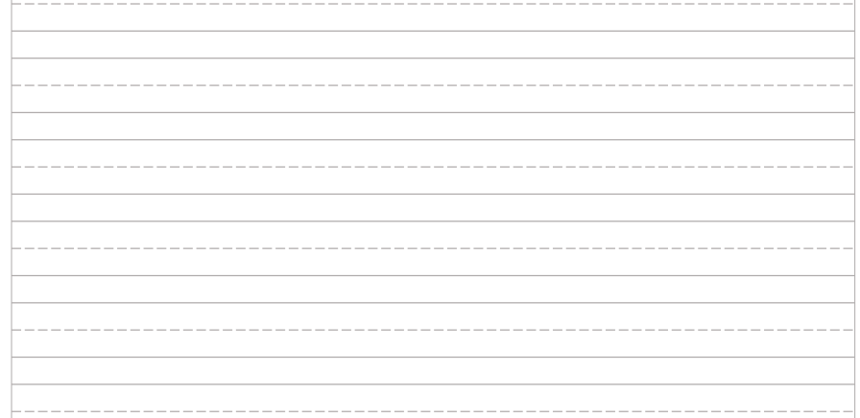

Y3 onwards (1cm from top dotted line to bottom dotted line)
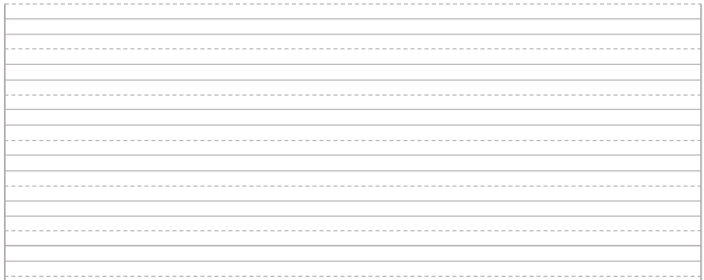

From Y2- 6 children will practice to use guide lines behind the plain paper with paperclips to hold the paper. There will be times when all children will work on plain paper and regular lined paper.

SEN and writing
We have a range of programmes to support fine motor skills, these include:
- Teodorescu programme
- Adapted pencil grips
- Triangular pencils
- Lined paper of different sizes and we will focus on a size that is right for the child and then build up to developing handwriting through the years.
- Dough disco
- PE warm up routines ensure shoulder and arm muscles are developed in order to support maturation of fine motor skills

The Role of Parents and Carers
Parents are encouraged to offer good models to their child by using only capital letters for proper nouns, practising drawing patterns together, playing joining up games which encourage left to right directionality.

