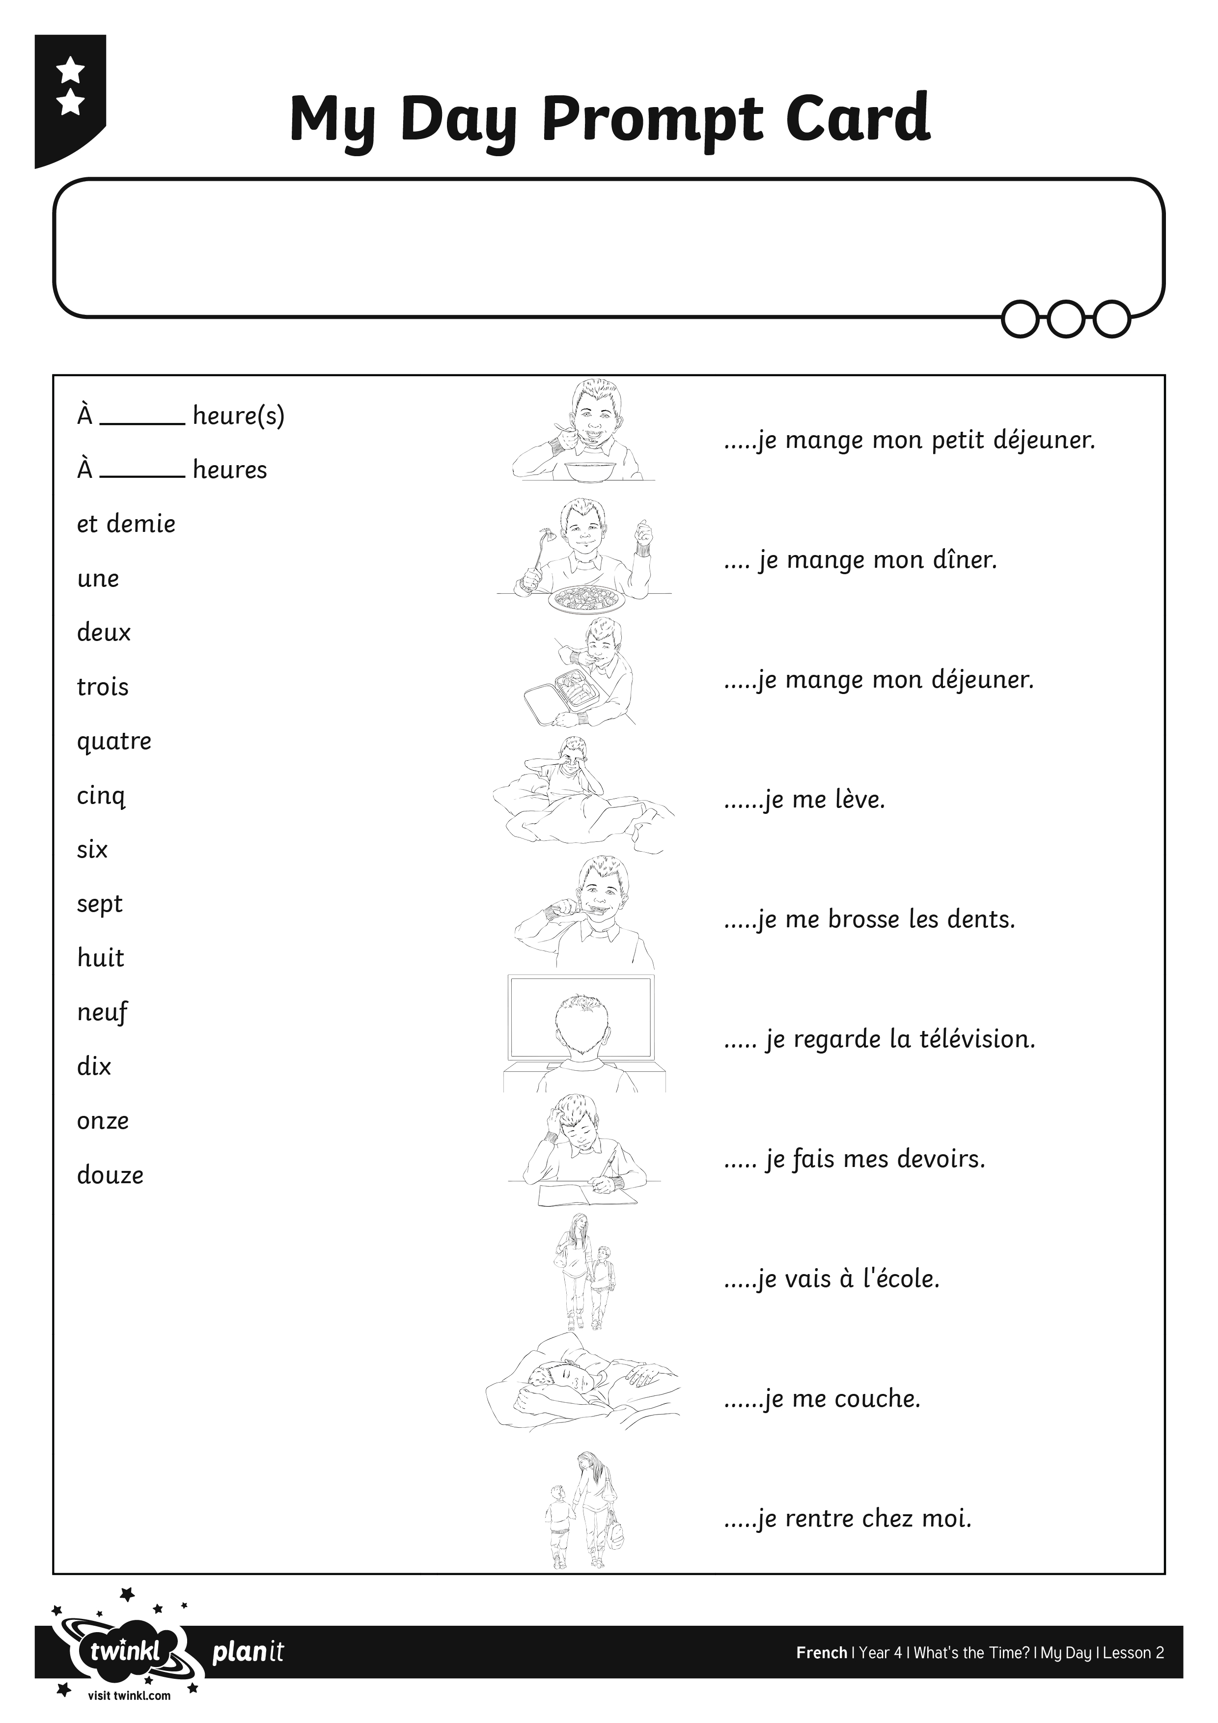
I can say and write at what time I do things.

I can say and write at what time I do things.

I can say and write at what time I do things.

