Mathematics

- Count to 20 and back.
- Count reliably at least 10 objects.
- Use ‘more’ and ‘less’ to compare two numbers.
- Estimate number of objects and check by counting.
- Recognise written numerals 1 to 9.
- Say one more/less (to 10).
- Add two small groups of objects (to 10).
- Use simple addition and subtraction to solve practical problems (inc. money)
- Begin to tell the time to the hour
- Formulate simple number sentences.
- Calculate how many are left from a larger number by counting back.
- Use everyday language to describe and compare size, weight, capacity, time, position and distance
- Know and talk about patterns and the properties

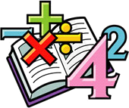

Kirk Smeaton CE Primary School

End of Year Expectations
for EYFS

This booklet provides information for parents and carers on the end of year expectations for children in our school. We have identified these expectations as being the minimum requirements your child must meet in order to ensure continued progress throughout the following year.
All the objectives will be worked on throughout the year and will be the focus of direct teaching. Any extra support you can provide in helping your children to achieve these at home would be appreciated.
If you have any queries regarding the content of this booklet or want support in knowing how best to help your child, please talk to your child’s teacher.

Reading

- Enjoy rhyming and rhythmic activities.
- Distinguish one sound from another - letters and sounds
- Show awareness of rhyme and alliteration.
- Recognise rhyme in spoken words.
- Read up to 100 familiar words.
- Can sound out CVC /CCVC/CVCC words without prompt. (CVC = Consonant-Vowel-Consonant)
- Able to predict what happens next in stories.
- Know difference between fiction and non-fiction books.
- Know to stop at a full stop.
- Weekly guided reading with every group.
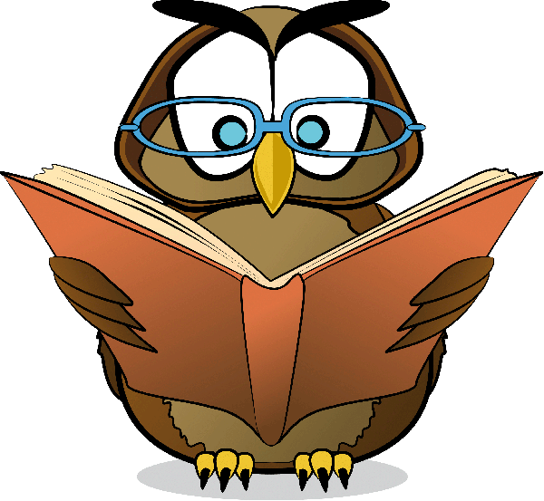

Writing

- Form majority of letters correctly.
- Hold pencil correctly.
- High frequency words must be spelled correctly
- Other words spelled phonetically plausibly
- Begin to write simple sentences with awareness of capital letters and full stops
- Write own name.
- Write labels and captions.

