** Kirk Smeaton C of E Primary School**

**E Safety policy including mobile phones and smart devices.**

Sept 24

**Introduction**

This policy is written in conjunction with North Yorkshire E-safety guidance, safeguarding audit, curriculum policies, data protection policy, anti-bullying policy and safeguarding children policies and procedures. The Headteacher is the e-safety co-ordinator.

**Rationale**

The internet and other digital technologies permeate all aspects of life in a modern technological society. Internet use is part of the statutory National Curriculum and is a necessary tool for staff and pupils. It is the entitlement of every pupil to have access to the internet and digital technologies, in order to enrich his/her learning.

**Aims**

Our aims are to ensure that all pupils, including those with special educational needs:

* will use the internet and other digital technologies to support, extend and enhance their learning;
* will develop an understanding of the uses, importance and limitations of the internet;
* digital technologies in the modern world including the need to avoid undesirable material;
* will develop a positive attitude to the internet and develop their IT capability through both;
* ensure all users can access the internet and devices safely;
* independent and collaborative working;
* will use existing, as well as up and coming, technologies safely.
* Promote, and set an example for, safe and responsible phone use
* Set clear guidelines for the use of mobile phones for pupils, staff, parents/carers and volunteers
* Risk of theft, loss, or damage

**Internet use will support, extend and enhance learning**

* Pupils will be given clear objectives for internet use.
* Web content will be subject to age-appropriate filters in school.
* Internet safety will be given to parents to support them with home internet security.
* Internet use will be embedded in the curriculum.

**Pupils will develop an understanding of the uses, importance and limitations of the internet**

* Pupils will be taught how to effectively use the internet for research purposes.
* Pupils will be taught to evaluate information on the internet.
* Pupils will be taught how to report inappropriate web content.
* Pupils will develop a positive attitude to the internet and develop their ICT capability through both independent and collaborative working.
* Pupils will use the internet to enhance their learning experience.
* Pupils have opportunities to engage in independent and collaborative learning using the internet and other digital technologies.

**Data Protection**

* Staff must not use their personal mobile phones to process personal data, or any other confidential school information, including entering such data into generative artificial intelligence (AI) tools such as chatbots (e.g. ChatGPT and Google Bard).

**E-mail**

* Pupils and staff will only use approved e-mail accounts when using the school network.
* Pupils will tell a member of staff and parents if they receive inappropriate e-mail communications, they will be supported in reporting these to <https://www.ceop.police.uk/Safety-Centre/>

I**nternet Access and Learning Platform**

* Staff will read and sign the NYCC Acceptable Use Policy – ICT and e-Technology before using any school ICT resource.
* Pupils will be taught to use the internet responsibly and to report any inappropriate content to a responsible adult. These are taught from the guidance published by the government in 2019 <https://assets.publishing.service.gov.uk/government/uploads/system/uploads/attachment_data/file/811796/Teaching_online_safety_in_school.pdf>

**Mobile Phones and other smart devices**

Pupils are only permitted to have mobile phones or other smart devices in school with the permission of the Headteacher. See Appendix B: permission form allowing a pupil to bring their phone to school.

Phones will be stored in the class teachers draw at the start of the school day and will be given back to the child at the end of the school day. All phones need to be off. Pupils will not use the phone during the school day unless directed to by the Headteacher.

We encourage children to wear analogue watches should they wish to wear a watch.

The school accepts no responsibility for mobile phones/devices/property that are lost, damaged or stolen on school premises or transport, during school visits or trips, or while pupils are travelling to and from school.

When pupils are using smart devices they will be required to follow the school’s Acceptable Use Policy (AUP). Such items can be confiscated by school staff if they have reason to think that they are being used to compromise the wellbeing and safety of others (Education and Inspections Act 2006, Sections 90, 91 and 94).

School Website and Published Content

* There is a separate website policy.
* All staff who edit website content must read and sign this policy.

**Staff- personal mobiles for work purposes**

Staff (including volunteers, contractors and anyone else otherwise engaged by the school) are not permitted to make or receive calls, or send texts, while [children are present/during contact time]. Use of personal mobile phones must be restricted to non-contact time, and to areas of the school where pupils are not present (such as the staffroom, cloakroom).

There may be circumstances in which it’s appropriate for a member of staff to have use of their phone during contact time. For instance:

For emergency contact by their child, or their child’s school

In the case of acutely ill dependents or family members

The headteacher will decide on a case-by-basis whether to allow for special arrangements.

If special arrangements are not deemed necessary, school staff can use the school office number [01977620497] as a point of emergency contact.

In some circumstances, it may be appropriate for staff to use personal mobile phones for work. Such circumstances may include, but aren’t limited to:

Emergency evacuations

Supervising off-site trips

Supervising residential visits

In these circumstances, staff will:

Use their mobile phones in an appropriate and professional manner, in line with our staff code of conduct

Not use their phones to take photographs or recordings of pupils, their work, or anything else which could identify a pupil

Refrain from using their phones to contact parents/carers. If necessary, contact must be made via the school office

**Systems Security**

* IT systems security will be regularly reviewed with support from Schools ICT and Leger.

**Web Filtering**

* The school will work with Schools ICT to ensure that appropriate filtering is in place.
* Pupils will report any inappropriate content accessed to an appropriate member of staff.

**School internet safety rules and procedures**

* E-safety rules are within the schools SHINE rules and are displayed around school.
* All children are given rules on how to behave on live lessons
* Pupils will be informed that internet and Learning Platform use will be monitored.
* e-Safety will be included in the curriculum and regularly revisited in accordance with the guidance from the government. Staff will use a PPT slides below (appendix A)
* Staff will be monitoring internet and Learning Platform.
* Communication of the e-safety policy to parents/carers
* The acceptable use policies will be available in the school prospectus and on the school website.
* The school website and dojo will include a list of e-safety resources and information for parents to access.
* The school will communicate and publicise e-safety issues to parents through the school newsletter and website.

**Rules for live lessons**

1. All parties to be respectful.
2. All parties to mute their screens, unless they have been invited to speak by the host.
3. All parties can display their screen or disable the camera if they wish.
4. If the camera is displayed, we ask for all parties to sit still and quiet during the session.
5. All parties are asked to wait a waiting room until they are asked to join the meeting. If they have not provided their first name and the first letter of the surname, they will be asked to change their name and they can be added to the meeting.
6. All meetings have a password and are recorded.
7. If children are accessing the live session from school, the camera will be disabled or directed at the teacher.
8. If someone wants to talk, they raise their hand.
9. Please be respectful with the chat facility and the content being shared.
10. Do not share the meeting ID or password with others and do not print screen or film the content being shared.

**E-safety Complaints**

* Instances of pupil internet or Learning Platform misuse should be reported to a member of staff.
* Staff will be trained so they are able to deal with e-Safety incidents. They must log incidents reported to them and if necessary refer the matter to a senior member of staff.
* Instances of staff internet or Learning Platform misuse should be reported to, and will be dealt with by, the Headteacher.
* Pupils and parents will be informed of the consequences of internet and/or Learning Platform misuse.

**Safeguarding**

Staff must refrain from giving their personal contact details to parents/carers or pupils, including connecting through social media and messaging apps. Staff must avoid publicising their contact details on any social media platform or website, to avoid unwanted contact by parents/carers or pupils.

Parents are asked for written permission for taking images/videos of their children and how and where these images are used (photograph and video policy). All photos and videos taken are taken on school equipment, staff only take photos/videos that are to be shared on dojo or websites, photos are uploaded to dojo and/ or the school server.

**Whole-School Responsibilities**

**Staff**

* All staff (including teachers, support staff and supply staff) are responsible for enforcing this policy.
* Volunteers, or anyone else otherwise engaged by the school, must alert a member of staff if they witness, or are aware of, a breach of this policy.
* The Headteacher is responsible for monitoring the policy every 2 years, reviewing it, and holding staff and pupils accountable for its implementation.

**Headteacher**

* Responsible for e-safety issues within the school but may delegate the day-to-day responsibility to a member of staff.
* Ensure that developments at Local Authority level are communicated to the e-safety co-ordinator.
* Ensure that the Governing Body is informed of e-safety issues and policies.
* Ensure that appropriate funding is allocated to support e-safety activities throughout the school.
* Establish and maintain a school-wide e-safety programme.
* Form a school e-safety team to review and advise on e-safety policies.
* Work with the e-safety team to develop, and review, e-safety policies and procedures.
* Respond to e-safety policy breaches in an appropriate and consistent manner in line with protocols set out in policies, and maintain an incident log.
* The Headteacher may act on online safety incidents outside of school that affect the wellbeing of staff and learners.
* Form a school e-safety management team to review the effectiveness and impact of the policy.
* Establish and maintain a staff professional development programme relating to e-Safety.
* Develop an understanding of relevant legislation and take responsibility for their professional development in this area.

**Governing Body**

* Appoint an e-Safety Governor who will ensure that e-safety is included as part of the regular review of child protection and health and safety policies.
* Support the Headteacher and/or designated e-safety co-ordinator in establishing and implementing policies, systems and procedures for ensuring a safe IT learning environment.
* Ensure that appropriate funding is authorised for e-safety solutions, training and other activities as recommended by the Headteacher and/or designated e-safety co-ordinator (as part of the wider remit of the Governing Body with regards to school budgets).

**E safety in the curriculum**

* All children are taught the importance of tell an adult if there is content that upsets them.
* All children are taught the importance of being responsible on the internet.

Reception and Nursery

* All Children will have access to devices, usually IPADS and tablets, where APPS are ready for children to engage with.
* In Reception there is preparation on devices to log into learning platforms ie. spellingshed. This is to support the child to know how to access learning APPS and create some independence. Logins are shared with parents to support them at home.

Y1 and Y2

* All children have access to devices in the classroom, usually IPADS and tablets.
* They have personalised log ins on the school laptops.
* Children are able to use APPS and searches to research topics, spellings and general class-based questions.

KS2

* Children have access to devices in the classroom. They are able to access tablets throughout the day for Rockstars, spellingshed, IDL programmes and other websites to support learning.
* They have access to Laptops and have personalised log ins. Laptops are used for programmes such as word, excel and general use of the internet.

Appendix A

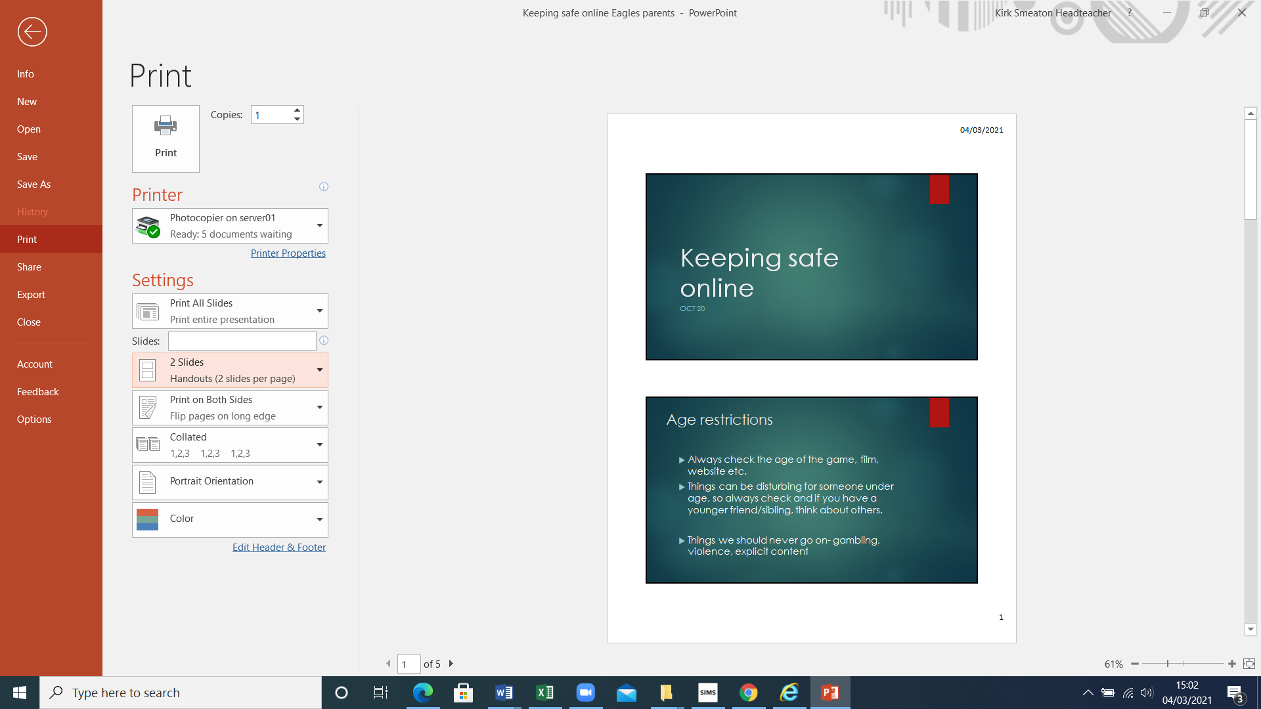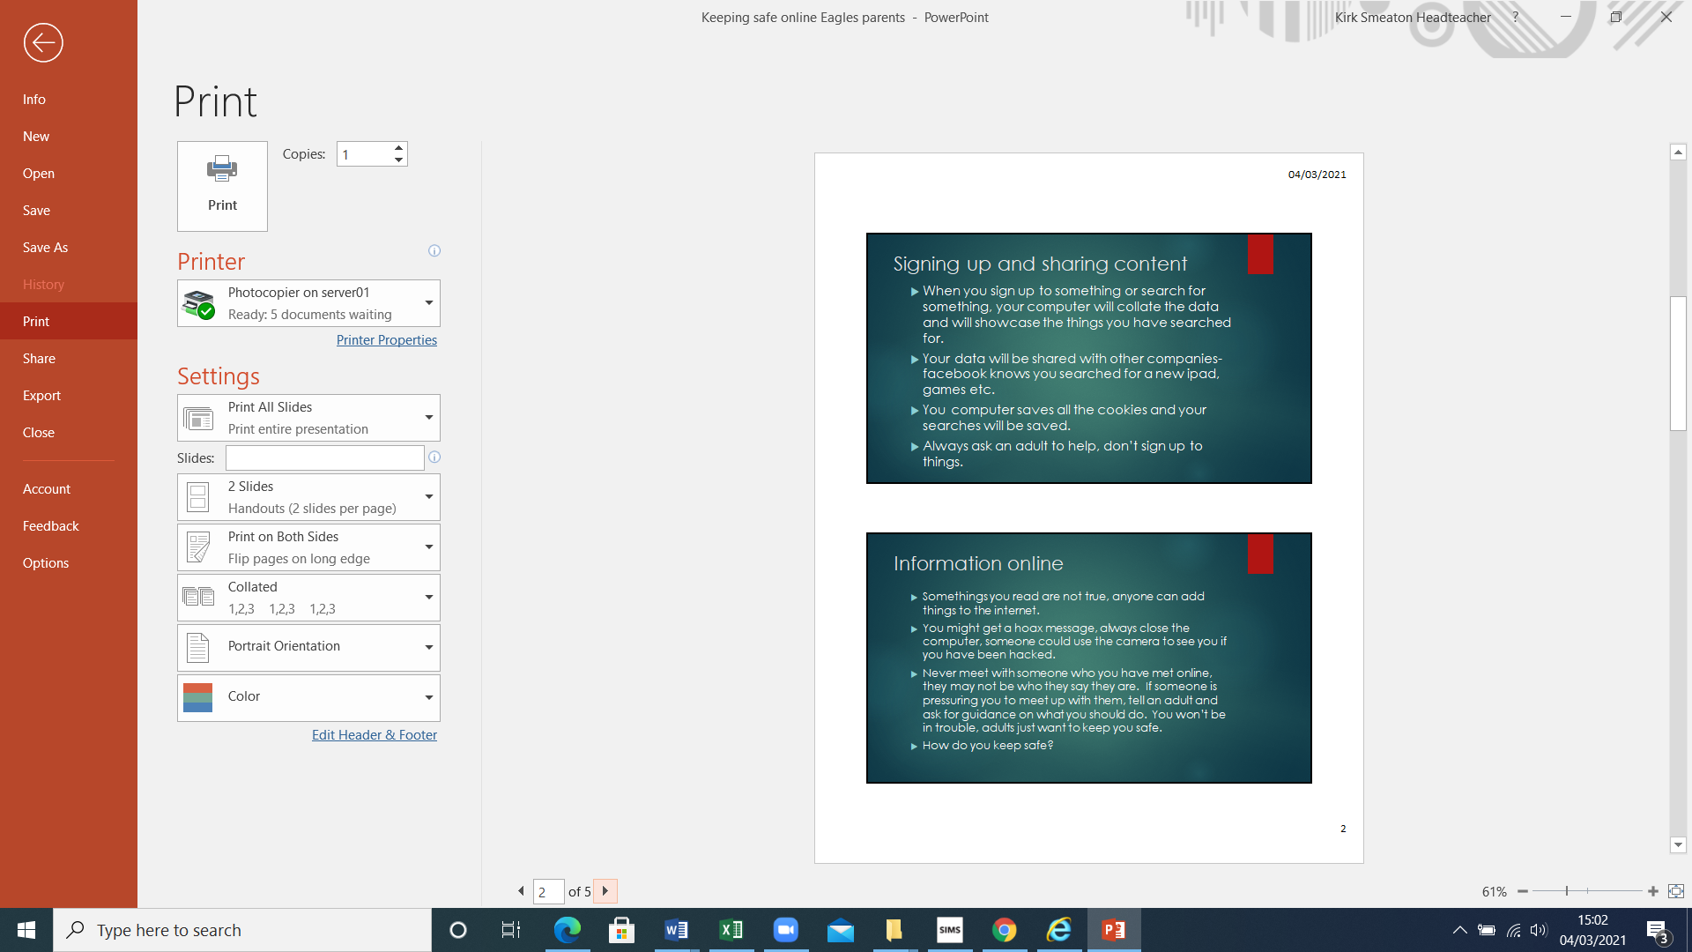

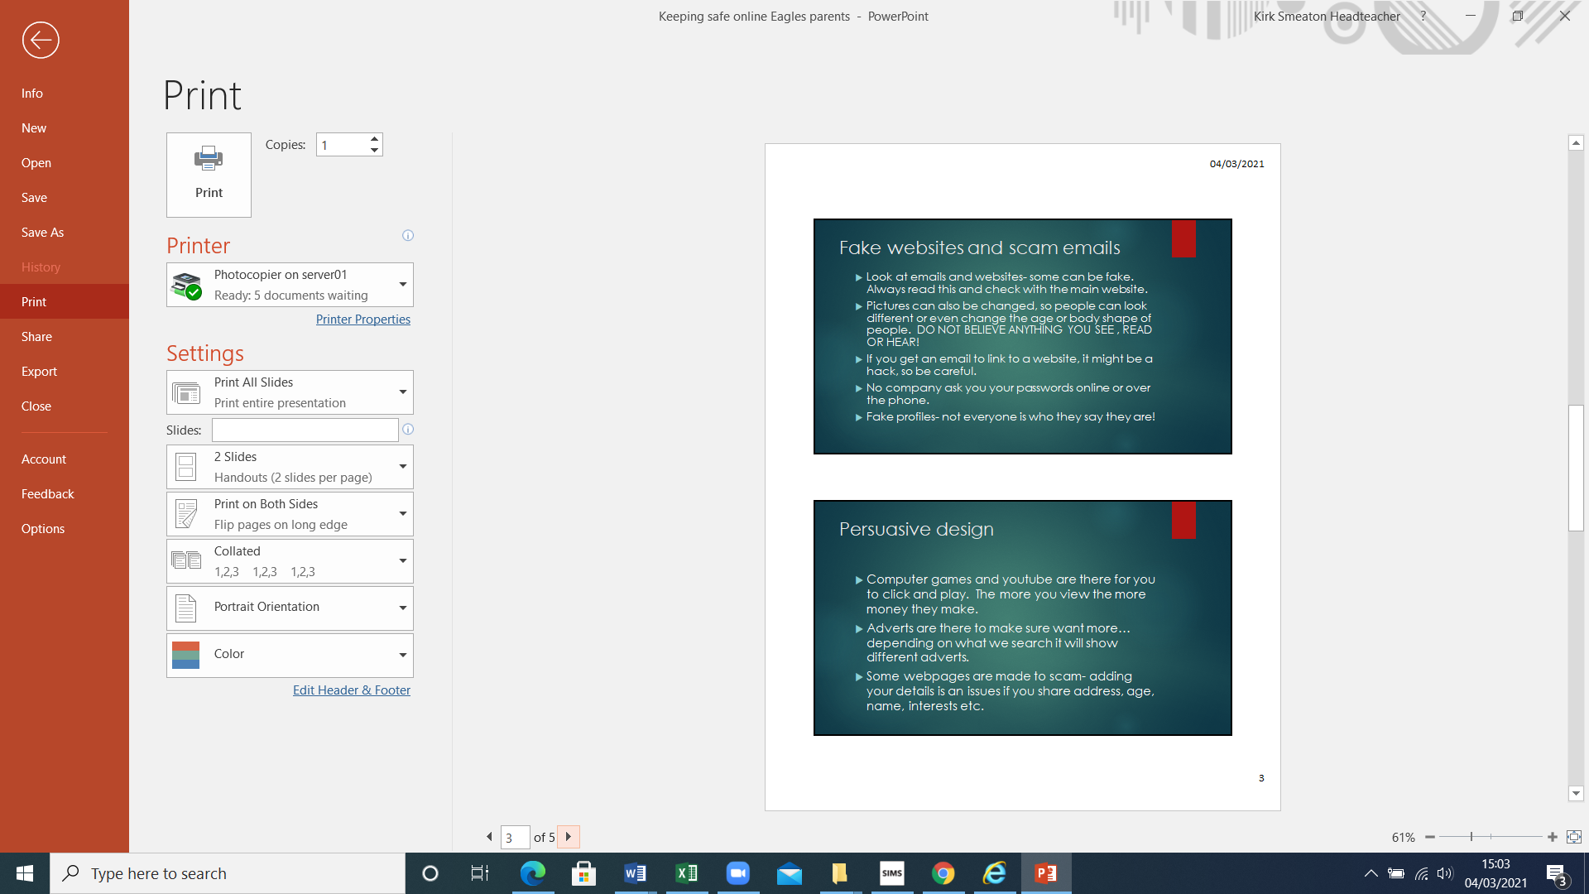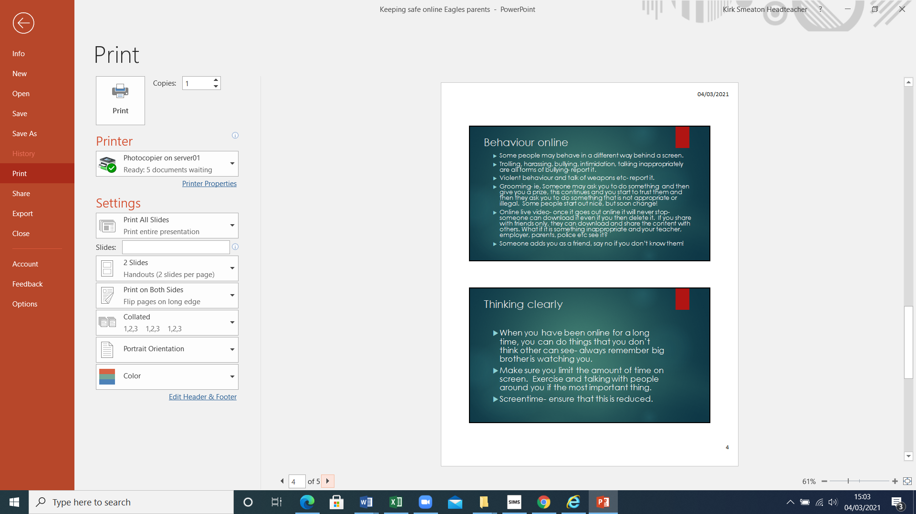

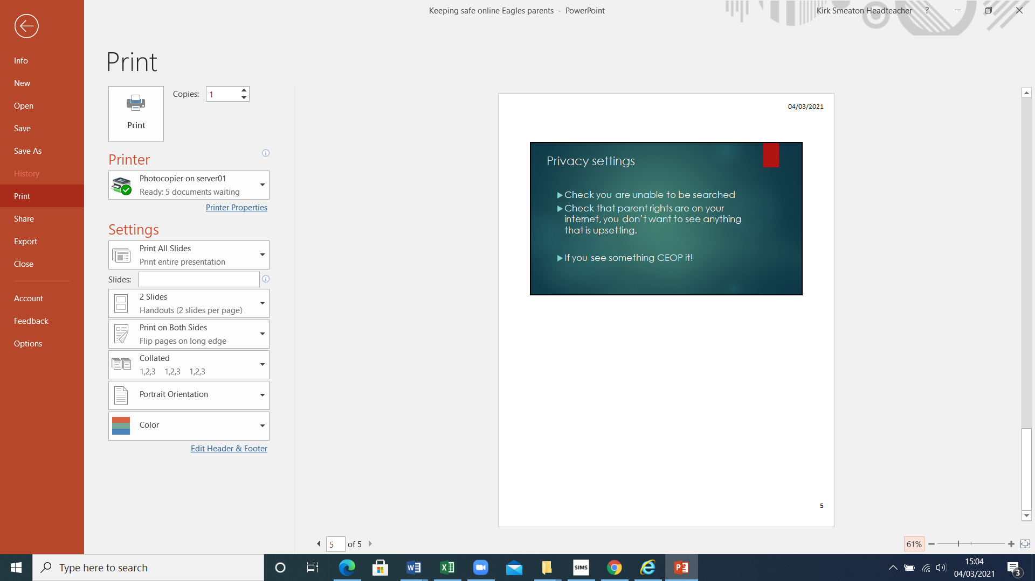

### Appendix B: Permission form allowing a pupil to bring their phone to school

| pupil details | |
| --- | --- |
| **Pupil name:** |  |
| **Year group/class:** |  |
| **Parent/carer(s) name(s):** |  |

The school has agreed to allow ________________to bring their mobile phone to school because they (tick one):

* Travel to and from school alone
* Are a young carer.
* Other _________________________________________________________________________

______________________________________________________________________________

Pupils who bring a mobile phone to school must abide by the school’s policy on the use of mobile phones, and its acceptable use agreement.

The school reserves the right revoke permission if pupils don’t abide by the policy.

Parent/carer signature: _____________________________________

| For school use only | |
| --- | --- |
| **Authorised by:** |  |
| **Date:** |  |