Build a famous Landmark Challenge!
Ideas to get you going….
The Leaning Tower of Pisa L’Arc du Triomphe Stonehenge
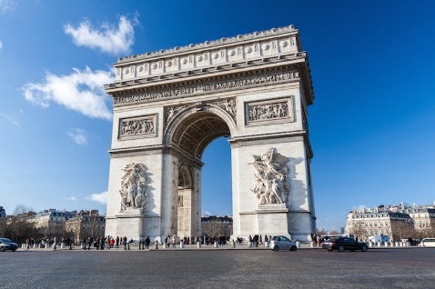
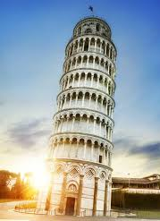
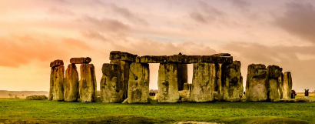

Fancy something trickier?

Le Tour Eiffel Tower Bridge Ancient Pyramids
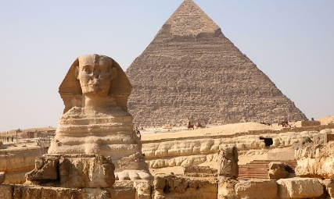
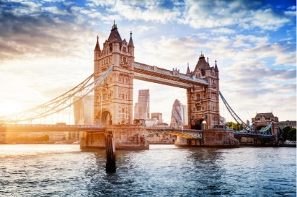
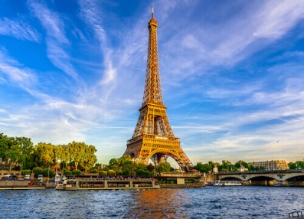

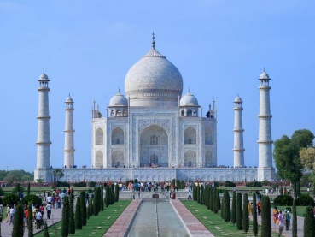
For those expert builders out there…

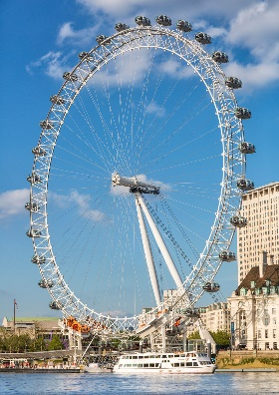
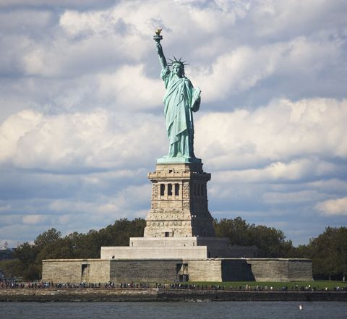
The Taj Mahal The Statue of Liberty The London Eye

