5 on the Clock

Stage: 2 Challenge Level:

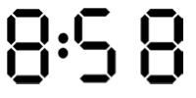
On a digital clock showing 24 -hour time, over a whole day, how many times does a 5 appear?
Is it the same number for a 12 -hour clock over a whole day?

