Maths SATs paper 3: reasoning

First name
Middle name
Last name
Date of birth | Day | Month | Year
School name

Instructions
You must not use a calculator to answer any questions in this test.

Questions and answers
You have 40 minutes to complete this test.
Follow the instructions for each question.
Work as quickly and as carefully as you can.
If you need to do working out, you can use the space around the question.

Some questions have a method box like this:

Show your method

For these questions, you may get a mark for showing your method.
If you cannot do a question, go onto the next one.
You can come back to it later, if you have time.
If you finish before the end, go back and check your work.
Marks
The number under each line at the side of the page tells you the maximum number of marks for each question.

- What is the next integer after 4099?

1 mark
2. Complete this table with the missing numbers.
The first row has been done for you.
Number | 1000 less
7,500 | 6,500
1,643
 | 4,099
 | 10, 078
2 marks
3. Write two factors of 24 that are not factors of 36.

1 mark
7.56 | x |  | = | 7560
4. Complete the statement

1 mark

$$<$$ | $$>$$ | =
5. Look at these symbols

Write one in each statement below to make it true.
a. | 2 ¾ |  | 2.75
b. | ¼ of 20 |  | 4
c. | 2³ |  | 3²

2 marks

6. Rachel buys four tee-shirts at £3.20 each.
She pays with a £20 pound note.
What change does she get back?

2 marks

7. These two identical triangles make a parallelogram.
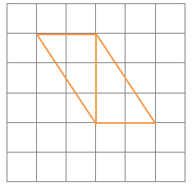
Draw another identical triangle in each of the boxes below to make the given shape:
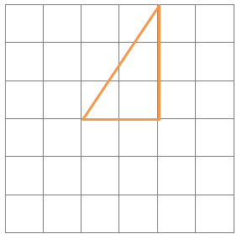  rectangle |  | 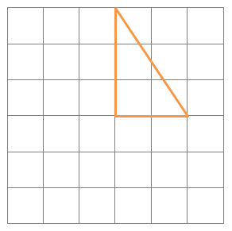  A different parallelogram to the example above
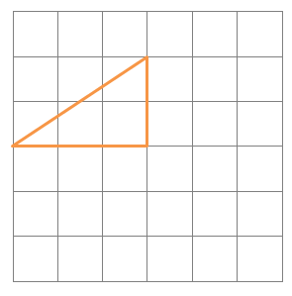  bigger triangle |  | Different bigger triangle
4 marks

8. Find the missing angles:
a. | ?
b. | 63°  ?
2 marks
9. Ric and his three friends buy a ticket for a football game. They each gave Ric a £5 note. He
bought the tickets and received £3.20 in change.

- How many tickets does he buy?

1 mark
- How much does one ticket cost?

£

2 marks

10. These cuboids are made up of small cubes.
Write how many small cubes there are in each cuboid or shape below.
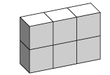
Number of cubes 6

a. | 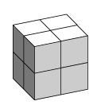  Number of cubes |  | b. | 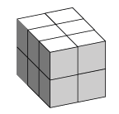  Number of cubes
c. | 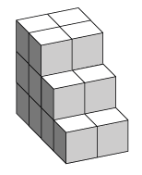  Number of cubes |  | d. | 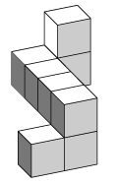  Number of cubes

4 marks
11. This pie chart shows how a group of 32 pupils travel to school.

Complete the following table.
The number who travelled by Metro is already filled in.

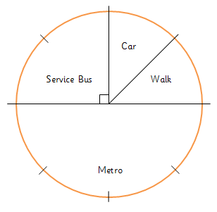
Travel | Metro | Service Bus | Car | Walk
Number of Children | 16

12. Fill in the first box to make the statement true.
 | ÷ | 4 | + | 3 | = | 7

1 mark

13. This triangle has an area of 6cm².
On the grids below, can you draw the following shapes with the same area?
a. a different triangle,
b. a rectangle, and
c. a parallelogram.
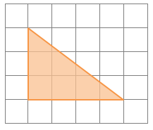
different triangle |  | rectangle
parallelogram

3 marks

14. Look at this bus timetable from Gateshead to Washington:
Bus Timetable: Gateshead to Washington
Gateshead depart: | 17:45 | 18:30 | 19:30 | 20:45 | 21:30
Washington arrive: | 18:30 | 19:15 | 20:15 | 21:30 | 22:15

a. A bus leaves Gateshead at 18:30.
What time does it arrive in Washington?

1 mark
b. Rama lives in Washington. He needs to be back home for 9pm.
What is the latest bus he can get from Gateshead?

1 mark
c. Sita is 20 minutes too late for the 19:30 bus from Gateshead.
She catches the next bus instead.
How long does she need to wait for the next bus?

1 mark
15. In each part, put a tick () by the statement which is most likely to be true.
My bathroom door is 2mm high
My bathroom door is 2cm high
My bathroom door is 2m high
a.

1 mark
The kettle in my kitchen holds 2.5 litres of water
The kettle in my kitchen holds 25 litres of water
The kettle in my kitchen holds 250 litres of water
b.

1 mark

The orange in my bag weighs 10 grams
The orange in my bag weighs 100 grams
The orange in my bag weighs 1000 grams
c.

1 mark
16. Circle the number that is half of 99.
44.5 | 45.5 | 50% | 49.5 | 33

1 mark

17. The diagram below shows that the number six is half-way between the numbers two and ten.
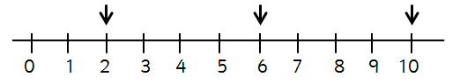
a. What number is half-way between -2 and 6?

1 mark
b. The number seven is half-way between the number one and another.
What is the other number?

1 mark
18.

a. Shade $\frac{3}{5}$ of the diagram.
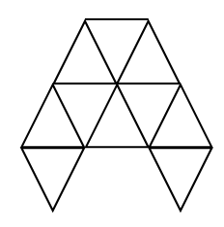
1 mark
b. What percentage of the diagram have you shaded?

%

1 mark
19. The numbers 1, 2, 3 and 4 can be written as the following sums:
eg. 3 + 2 + 1 + 4 = 10 and (3 + 2) × (1 + 4) = 25
Using the symbols: +, -, ×, ÷, and ( ), make the following statements true.
a. | 3 | 2 | 1 | 4 | = | 9
b. | 3 | 2 | 1 | 4 | = | 3
c. | 3 | 2 | 1 | 4 | = | 0

3 marks

20.
a. Aisha thinks of a number. She doubles it, then subtracts five and gets the answer 7.
What was the number she was thinking of?

1 mark
b. Kias repeats the above process and gets the same answer as what he started with.
What was the number he started with?

1 mark

21. Here is an example of a 2cm cube.
Its volume is 8cm³.

How many of these 2cm cubes could fit exactly into a cuboid with dimensions 20cm by 12cm by 8cm?
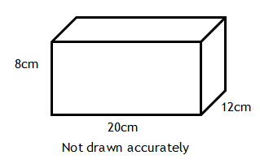

cubes

2 marks
22. Complete the following statements
a. 50% of £12 = | £
b. 25% of |  | = £7

1 mark

1 mark
23. A square has a perimeter of 24cm.

Not drawn accurately
A rectangle has a perimeter of 16cm

Not drawn accurately
The rectangle is joined onto the square to make a larger rectangle.

Work out the perimeter of this larger rectangle.

cm

2 marks
The end
Answers
Qu. | Requirement | Mark | Additional Guidance
1. | 4,100 | 1 | Note: 5,000 is popular error
2. | Number 1000 less  7,500 6,500  1,643 643  5,099 4,099  11,078 10,078 | 1  1 | Allow 1 mark if they get the first answer and any one of next two correct.
3. | 8 and 24 | 1
4. | 7.56 x 1000 = 7560 | 1
5. | =  >  < | 1  1  1 | ¼ of 20 = 5  2³ = 8; 3² = 9
6. | Cost of 4 = 4 x £3.20 = £12.80  Change = £20 - £12.80  = £7.20 | 1  1
7. | 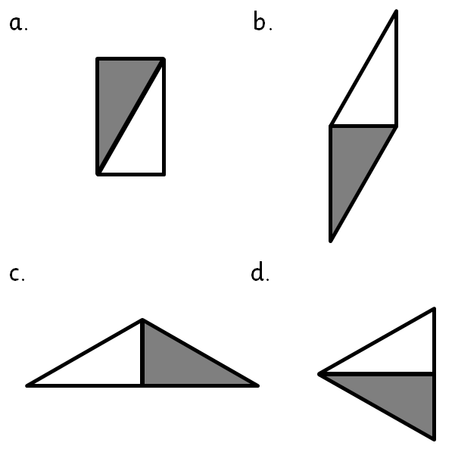 | 1  1  1  1 | Accept diagrams in reverse order for (c) and (d)

8. | a. 60°  b. 63° | 2 | Allow 1 mark for each correct answer.
9. | a. 4 x £5 = £20  b.Cost =£20 - £3.20=  = £16.80  Single cost = £16.80 ÷ 4  = £4.20 | 1  1  1 | Look for arithmetic accuracy  Alternative: for ONE person  change = £3.20÷ 4 = £0.80[1]  Cost = £5- £0.80 = £4.20 [1]
10. | a. 8  b. 12  c. 18  d. 8 | 1  1  1  1 | Allow correct answers only
11. | Metro = 16  Special Bus = 8  Car = 4  Walk = 4 | 1  1 | Allow any two correct for  1 mark
12. | 16 | 1
13. | 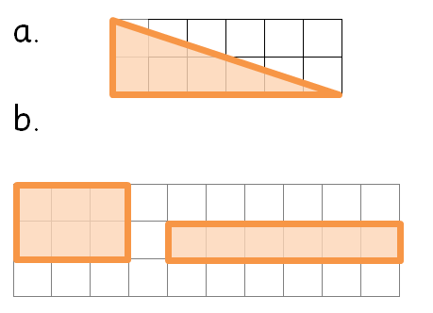 | 1  1 | 6 by 2 or 2 by 6 (rotation)  3 by 2 or 6 by 1

 | 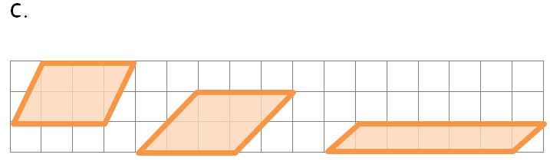 | 1 | Equivalent to (b)  Eg. base = 3;  Perpendicular height = 2
14. | a. 19:15  b.19:30  c. 55 minutes | 1  1  1
15. | a. 2m  b. 2.5 litres  c. 100 grams | 1  1  1
16. | 49.5 | 1 | Accept 49½ written
17. | a. 2  b. 13 | 1  1
18. | - shade in any 6 squares  - 60% | 1  1 | Allow ½ as along as they add to 6.
19. | a. 3 x 2 - 1 + 4 = 9  b. 3 x 2 + 1 $$-$$ 4 = 3  c. ( 3 $$-$$ 2 $$-$$ 1 ) x 4 =0 | 1  1  1 | - Allow brackets (1 - 4)  - Allow ÷ 4 instead of × 4
20. | - Aisha = 6  - Kias = 5 | 1  1
21. | Volume of cuboid = 1920cm³  Number of cubes = 1920 ÷ 8  = 240 | 1  1 | Alternative: find how many cubes fit each length  eg. 20 ÷ 2 = 10; [1]  Tot = 10 × 6 ×4 = 240 [1]

22. | - £6  - £28 | 1  1
23. | Length of side of square = 6cm  Possible dimensions of rectangle  4 by 4; 5 by 3; 6 by 2; 7 by 1  New length = 6 + 2 = 8cm  Perimeter = (8) + 6 + (8) + 6  = 28cm | 1  1 | Accept any rectangle with a perimeter of 16cm  Must use correct rectangle  Only follow their rectangle for this final mark provided it has a perimeter =16cm
Total = 50 marks

